BUILDING AN AI UNIVERSITY

UF’S PARTNERSHIPS WITH EDUCATIONAL INSTITUTIONS
STRENTHENING ARTIFICIAL INTELLIGENCE RESOURCES THROUGHOUT FLORIDA
The University of Florida is committed to leveraging its artificial intelligence knowledge and resources by partnering with other institutions, thereby reaching far more people and having a far greater impact than it could alone. These partnerships strengthen, and are made possible by, the considerable investment UF has made in expanding the teaching of AI across the full breadth of our curriculum by adding 100 new AI faculty as well as new courses, certificates, minors, and majors. UF’s partnerships include other institutions of higher learning, primary and secondary schools, and private sector organizations as well. Here are examples:

UF AND FLORIDA A & M UNIVERSITY
These universities were awarded a $1.4 million, three-year National Science Foundation grant to help develop careers in artificial intelligence. The goal is to bring resources previously unavailable to Florida A&M students, and to enable students from outside traditional computer-science fields to develop basic AI competency. This collaboration ensures that a diverse AI-enabled workforce will be of varied interests, backgrounds, experiences, socioeconomic status, races, ethnicities, genders, and technical ability in the development, deployment, and evaluation of AI systems.

MIAMI DADE COLLEGE
Through a $1 million grant award to Miami Dade College by the National Science Foundation, University of Florida faculty will collaborate with the college’s faculty to create courses and
integrate AI into its curriculum. Courses began in fall 2022, and Miami Dade now offers a a college-credit certificate in artificial intelligence as a result of this collaboration.

PALM BEACH STATE COLLEGE
UF and Palm Beach State College received $1 million in federal funding to educate faculty in AI and create new course content to prepare PBSC students for high-tech, high-wage jobs.

ORANGE COUNTY (FLORIDA) PUBLIC SCHOOLS
In collaboration with Orange County (FL) Public Schools, the University of Florida is proposing a professional development model to upskill and support teachers who will be implementing the AI Foundations CTE framework that has been submitted to the Florida Department of Education.

OKALOOSA COUNTY SCHOOL DISTRICT
The University of Florida’s engineering faculty members are partnering with the Okaloosa School District in developing new programs from which they plan to develop middle-school frameworks in data science.

AI
UF’s Partnerships in Artificial Intelligence


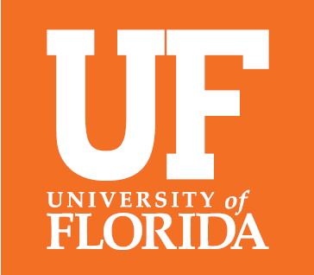


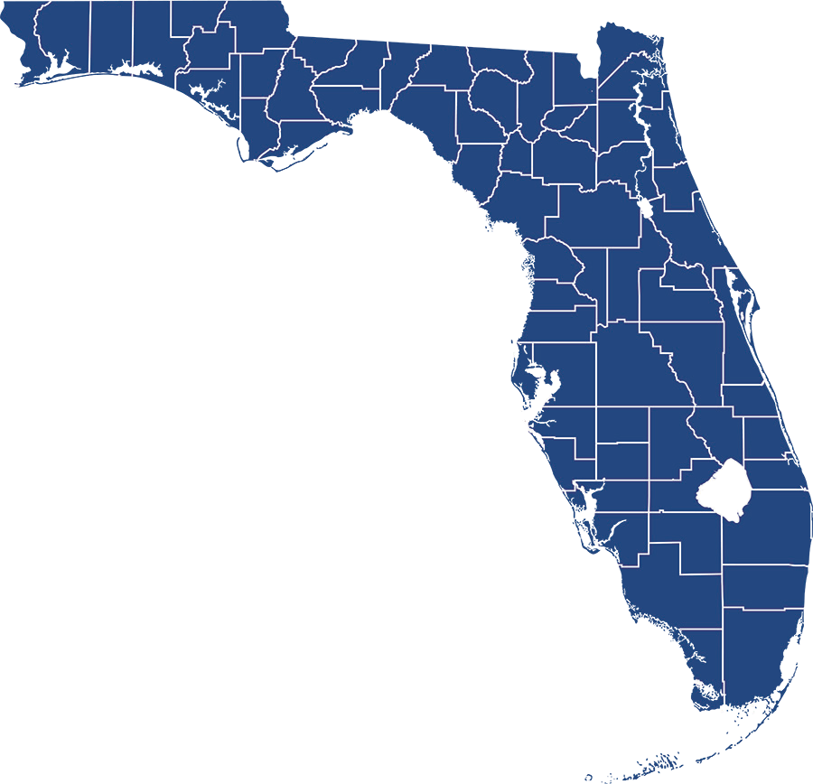

SOUTHEAST CONFERENCE ARTIFICIAL INTELLIGENCE CONSORTIUM
UNIVERSITY OF FLORIDA
AI ACROSS THE CURRICULUM
As the leader of the Southeast Conference Artificial Intelligence Consortium, the University of Florida is spearheading what may be the first athletics conference collaboration on AI
This collaboration will share educational resources, promote faculty and staff development, and seek joint partnerships with industry.
BUILDING AN AI UNIVERSITY

SEC ARTIFICIAL INTELLIGENCE CONSORTIUM

Current as of November 2022

