Building the Human Infrastructure for High-Performance Computing

Executive Summary
As universities expand their use of artificial intelligence and high-performance computing (HPC), many focus first on acquiring hardware, such as servers, GPUs, or cloud capacity. Yet experience across research institutions shows that the success of AI infrastructure depends far less on the machines themselves than on the human systems that support them. Universities that invest heavily in computational power without building the staffing, governance, and operational structures required to run it often find that their systems remain underutilized or difficult for faculty and students to access, leaving a lot of ideas and potential innovation untapped. Because AI is so pervasive in its potential impact, it requires people to bring ideas and visions to reliable, enterprise-level products, tools, and services. The people are not just a multiplier that enhances the value of the investments in machines, they enable transforming ideas into results.
High-performance computing is not simply a technology asset; it is an institutional capability built on layers of specialized expertise. System administrators maintain the reliability and security of the infrastructure. Support and training teams ensure that large communities of users can access the system effectively. Research software engineers and AI consultants work directly with faculty to translate disciplinary questions into scalable computational workflows. Together, these roles form the human infrastructure that transforms raw computing power into research productivity.
This support structure is essential regardless of the infrastructure model an institution adopts. Universities may access computing through cloud providers, consortium-based systems, or locally operated supercomputers. Consortium systems often manage the back-end operations, such as cluster architecture, installation, configuration, maintenance, security, resource scheduling and core software maintenance, but even in these cases, institutions remain responsible for user onboarding, training, configuring user-specific software environments, ensuring regulatory compliance, supporting researchers, and maintaining secure data practices. Cloud-based infrastructure typically provides only raw computational resources, leaving the bulk of operational and compliance responsibilities to the university. Outsourcing hardware or partial services does not eliminate the need for institutional expertise.
Building this human infrastructure presents its own strategic challenge. Universities must recruit and retain highly specialized staff consisting of research software engineers, AI consultants, research computing facilitators and advanced system administrators whose expertise is scarce and often in high demand in the private sector. These roles also do not always fit neatly within traditional academic job classifications, making recruitment and retention an important institutional consideration when developing AI infrastructure.
Successful universities therefore treat HPC not as a procurement decision but as an organizational system. They build layered teams that connect infrastructure operations with research and institutional service needs, allowing ideas to move efficiently from concept to implementation.
This paper outlines the core human roles required to support modern AI and high-performance computing environments and explains how these functions work together to enable scalable research. By investing in the people and processes that support computational infrastructure, universities can ensure that their AI investments translate into faster discovery, stronger research programs, and broader access to advanced computing across the academic community, as well as improve operational efficiency and capabilities for the institution.

Human Infrastructure: The Layered Model
AI infrastructure is not a standalone utility; it is a coordinated ecosystem of people, processes, and technology. The most effective research computing environments operate as a layered system in which each tier performs a distinct role. Separating these roles allows specialists to focus on what they do best. Mutual support and a strong focus on the mission are critical because a lack of intra-unit cooperation (siloing) removes much of the advantage of the cohesive and mutually supportive units.
At the foundation are the back-end operations and governance teams. These professionals maintain the computational bedrock, including networking, storage tiers, operating systems, and GPU clusters, while ensuring the environment remains secure, compliant, and operationally reliable. Their work is often invisible to faculty, but it is essential to institutional trust. Whether an institution relies on cloud infrastructure, a consortium resource, or its own supercomputer, this layer is responsible for uptime, operational integrity, and audit readiness.
Above this foundation sits the user support and training layer, which reduces friction between researchers and complex computing environments. Although the responsibility for training and educating can be addressed by many members of the team, this layer produces tutorials and documentation and delivers workshops and training programs. In large systems serving thousands of users, this layer functions like oil in an engine, smoothing the interaction between faculty and the machine so researchers can receive support for information technology troubleshooting on the basics as well as more sophisticated expertise for larger, more complex projects.
The top layer consists of AI consulting specialists and research software engineers (RSEs). These professionals work directly with faculty to translate disciplinary problems into computational workflows. Their work often begins with a conversation, sometimes in a hallway or during office hours, where a researcher describes a scientific question that may not yet have a clear computing pathway. The consulting team then helps convert that idea into a defined project with milestones, deliverables, and an implementation strategy.
Building these teams requires deliberate institutional planning. Many of the roles that support modern AI and HPC environments, particularly research software engineers, research computing facilitators and AI consulting specialists, are relatively new within universities and can be difficult to recruit. Individuals who possess both deep technical expertise and an understanding of academic research workflows are in high demand across the technology sector, often commanding salaries that exceed traditional university pay scales. As a result, institutions developing AI infrastructure must think strategically about career pathways, job classifications, and long-term retention for these positions. With the talent so much in demand, universities must view the activity of hiring and training talent for successful careers as part of their mission, hiring those who are willing to learn new things every day because AI moves so fast. It is likely that within a year or two, those people will become so good they will be hired away, at which time the university must hire again.

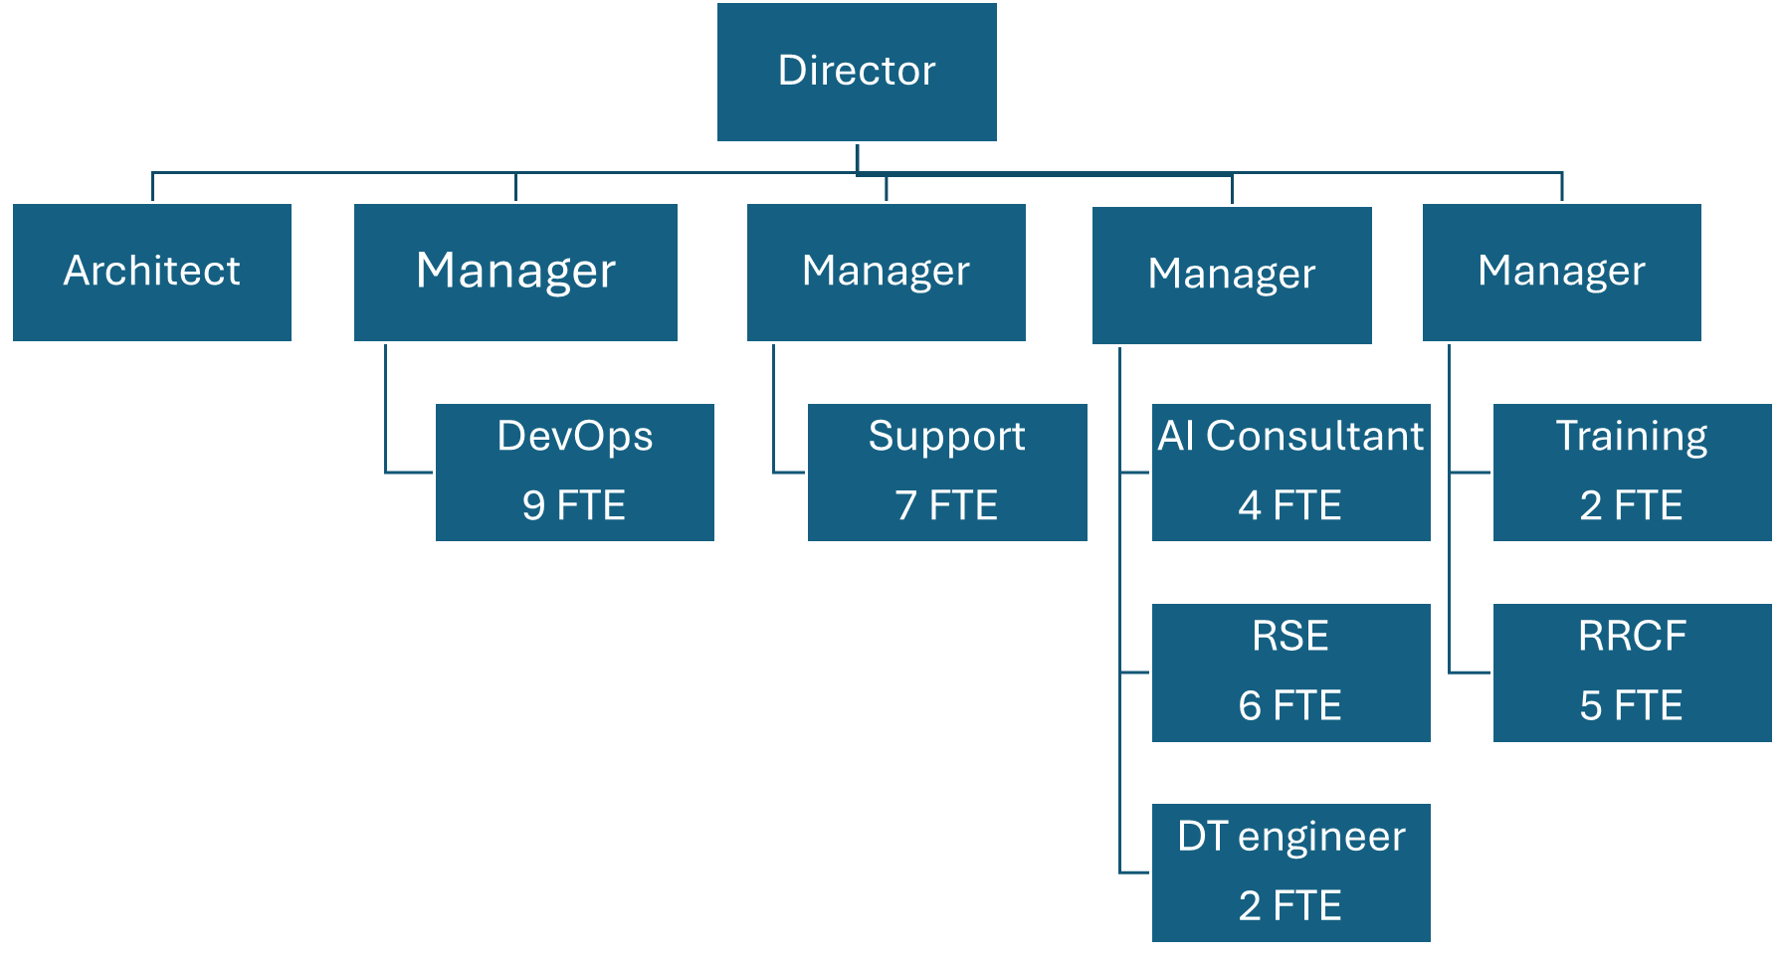
Staffing the Human Infrastructure
Teams with special expertise in UFIT Research Computing, which is the unit that supports the HiPerGator system and services. By column from the left: systems architect; systems development and operations team (9 FTE); support team (7 FTE); 4th column has the manager of the AI and advanced consulting team with 4 AI consultants, 6 research software engineers (RSE), and 2 digital twin engineers; 5th column shows the manager who supervises the training team (2 FTE) and the team of regulated research computing facilitators (RRCF) (5 FTE).

As demonstrated in the chart above, building effective AI infrastructure requires a full stack of talented professionals organized into complementary teams that can respond to faculty and institutional needs. The University of Florida’s Information Technology provides a model that has proven effective under high-demand and high-stress conditions over a period of 15 years.
At the top of the UFIT Research Computing structure is the Director, who oversees four managers, each responsible for one or more specialized teams. The managers work collaboratively with each other and with the director to ensure the system operates seamlessly and that faculty and researchers receive timely support. The university also employs an architect who oversees the design of the system as a cohesive set of services, ensuring interoperability and maintainability across the organization. Each team collaborates closely with the architect to align their work with the overall infrastructure strategy.
DevOps Team
The DevOps team, comprising nine staff members, manages the foundational layers of the infrastructure: hardware, firmware, and operating systems. This includes workload managers such as SLURM and Kubernetes, as well as hypervisors. They coordinate closely with the datacenter team to manage the physical infrastructure and ensure cybersecurity compliance, including HITRUST certification. Staff are experienced system administrators, network and storage engineers, and cybersecurity specialists, spanning multiple experience levels.
Support Team
The support team of seven manages software environments beyond the operating system, including libraries, frameworks, user applications, large amounts of hosted reference data, auxiliary services, user documentation, and application modification for cluster execution. Many staff members have advanced degrees and prior research experience. This team also handles support tickets submitted by users, which are initially triaged by a small help desk staffed by three to five undergraduate students.
Training Team
Two staff members develop and deliver both basic and advanced training workshops as well as a help chat, incorporating materials they create and third-party resources, such as those from the NVIDIA Deep Learning Institute. Staff in this team combine technical expertise with teaching experience to make complex systems accessible to faculty, researchers, and students.
Regulated Research Support
A team of five provides specialized consulting and software support for research that must meet regulatory standards, including NIST 800-53 Moderate, NIST 800-171, and CMMC compliance. Staff are skilled system administrators, cybersecurity engineers, and programmers who also possess the people skills to help researchers navigate regulatory constraints. Both the training and regulated research teams report to the same manager to maintain coordination.
AI and Advanced Consulting and Teams
The AI consulting team of ten provides advanced support for projects that need long-term maintenance, scaling and support. All team members work closely with each other and with the customer teams in any project; they also work with other teams in UFIT Research Computing as needed. The team includes:
- AI Consultants: Specialists who program, design workflows, and learn domain-specific knowledge to translate faculty research ideas into scalable computational solutions. Many staff members have advanced degrees, such as M.S. and Ph.D.
- Digital Twin Engineers: Experts in assembling and running digital twin ecosystems, including workflow design, programming, and visualization tools such as AR/VR (augmented reality and virtual reality).
- Research Software Engineers: Professional software engineers who typically manage up to three projects at a time, providing high-level development, testing, and deployment support.
This staffing structure demonstrates that successful AI infrastructure is inherently human-centric. Each layer, from DevOps to AI consulting, adds a critical capability that allows faculty to scale research ideas efficiently, meet compliance requirements, and accelerate the creation of functional, impactful tools. Without this human ecosystem, even the most powerful hardware or cloud resources cannot achieve their potential.

From Idea to Implementation: The Consulting Workflow
For many faculty members, particularly those in clinical, liberal arts, or professional disciplines, the barrier to AI adoption is not interest but implementation capacity. Recognizing this, some universities have moved beyond the traditional “account and training” model toward a full-stack consulting workflow that guides projects from concept to deployment.
The process typically begins with informal consultation. Faculty members often hesitate to submit formal technical requests when their ideas are still forming. To lower this barrier, institutions can maintain office hours and consultation spaces across campus where researchers can discuss initial concepts without the pressure of a formal ticketing system.
Once a project becomes clearer, the consulting team initiates a formal intake process. A short onboarding form captures the project’s goals, collaborators, and domain requirements. From this information, the team develops a statement of work defining the project’s scope, required resources, both hardware and people), roles and responsibilities, milestones, and technical approach. The team tries to help everyone but must sometimes prioritize based on the sensitivity of the project and other considerations – some researchers may need to wait.
During active development, a designated point person from the AI consulting team works directly with the principal investigator’s team. Weekly check-ins ensure that scientific objectives remain aligned with technical implementation. If new infrastructure requirements arise, such as additional storage, specialized GPUs, or custom software environments, the consulting team coordinates with system administrators and engineers to address them behind the scenes.
Projects typically conclude with deployment of a functional AI-powered software application, not simply a piece of code. The final output may be a secure web portal, a research dashboard, or an AI assistant or agent running behind an institutional login.
This consulting model transforms the university from a passive provider of computational resources into a factory for AI-enabled solutions, where faculty ideas move efficiently from concept to products or product-ready solutions.

Case Study: Scaling AI for Research Operations
One clear example of human infrastructure enabling operations at scale comes from a project for the Office of Research focused on improving how universities track and assess research activity. The team developed an AI-enabled search tool to identify all active and past research awards on campus. Tracking awards is challenging: project titles and descriptions often omit consistent keywords, meaning traditional searches return false hits or miss relevant projects entirely. The tool allows administrators, associate deans, and researchers to ask complex questions, for example, identifying faculty working in a specific research area or assessing the university’s AI-related projects overall.
While the team had the scientific insight and core AI methods, deploying this tool broadly required close collaboration with institutional research software engineers. The engineers optimized the workflow to run reliably on HiPerGator, connected the tool to live data sources, ensured secure access behind university login systems, and structured it so that groups across campus could easily use it. Regular weekly meetings allowed the teams and the engineers to iterate on improvements, scale the system, and make it accessible to multiple users simultaneously. In other words, the compute resources alone were insufficient; the human infrastructure, engineers who understand both the research domain, high-performance systems, and the university IT infrastructure was what will turn the prototype into a functional, scalable tool.
The lesson is clear: AI capability without human infrastructure does not scale. Even when research teams develop novel AI methods, the combination of back-end expertise, front-end consulting, and operational support is essential to transform computational ideas into broadly usable, institution-wide research tools.

Cloud and Shared Consortium Systems
Some universities may choose a cloud and consortium-based system, which can provide flexibility and lower upfront costs. This is usually most well-suited for pilot research programs, emerging academic initiatives, and institutions still developing internal expertise.
However, these models do not eliminate the need for human infrastructure. Even when computational resources are rented, faculty still require expert guidance to configure environments, optimize workflows, and manage data securely. Front-end consulting teams remain essential for translating academic problems into scalable computing solutions.
Just as important, outsourcing hardware does not transfer institutional responsibility for software environments, data governance, or regulatory compliance. Universities remain responsible for ensuring that research workflows meet requirements related to sensitive data, including FERPA, HIPAA, export control regulations, and institutional security policies. Cloud providers may supply the infrastructure with documentation like SOC 2 Type 2 attesting that they take care of relevant infrastructure controls, but institutions must still configure secure environments, manage access controls, maintain auditable workflows, and assemble the full compliance documentation for any audits.
For this reason, universities relying on cloud or consortium systems must still invest in front-end AI specialists and research computing staff who can build compliant environments and guide researchers through best practices for handling sensitive data.
In practice, outsourcing hardware does not outsource the responsibility of supporting researchers. Universities that rely on cloud or shared systems must still invest in the people who make those systems usable and secure.

Core Principles for Institutional AI Infrastructure
Several principles consistently emerge from universities that have successfully integrated AI into research and teaching. These lessons reflect operational realities rather than theoretical best practices.
Human infrastructure determines success.
The effectiveness of AI infrastructure depends less on the scale of the hardware than on the people supporting it. Research software engineers, AI consultants, research computing facilitators, training staff, and system administrators transform raw compute into usable research tools. Institutions that invest heavily in hardware without building this human layer often struggle to translate computational capacity into scientific output.
Front-end consulting capacity is essential.
Faculty rarely arrive with fully developed AI workflows. They arrive with research questions. Universities therefore need specialists who can work with researchers to translate disciplinary problems into computational pipelines, optimize models, and scale experiments. Without this layer, even powerful computing systems remain underutilized and important innovation to the mission and operation of the institution remain unrealized.
Operational readiness must precede hardware investment.
Successful institutions treat AI infrastructure as an operational capability, not a procurement exercise. Governance frameworks, staffing models, compliance processes, and training programs should be established before major hardware investments are made. When these structures are in place, infrastructure deployments accelerate research rather than create new bottlenecks.
Compliance responsibilities remain with the institution.
Even when computational resources are outsourced, universities still retain responsibility for software configurations, data governance, and regulatory compliance. Sensitive and restricted research data, whether governed by FERPA, HIPAA, export control, or institutional policy, requires secure environments, access controls, and auditable workflows. Hardware providers supply infrastructure, but universities must still build and maintain compliant research environments.
Success requires long-term workforce planning and retention. The effectiveness of AI and high-performance computing infrastructure depends on specialized staff, such as research software engineers, AI consultants, research computing facilitators, and advanced system administrators, whose expertise spans both computational systems and academic research workflows. These roles are in high demand across both universities and the private sector, making recruitment and retention an ongoing challenge. Institutions developing AI infrastructure must therefore plan not only for initial hiring, but also for sustainable career pathways, competitive compensation where possible, professional development opportunities, and organizational structures that support long-term retention of this expertise. In this context, universities need to remember their mission as educational institutions, and consider a great employee being hired away as success, rather than a pure loss. Without sustained investment in these human capabilities, even well-funded computational systems can struggle to deliver their full research potential.

Conclusion
Universities that focus on hardware without investing in human infrastructure risk leaving powerful AI systems idle, frustrating researchers, and slowing the pace of discovery. The example of scaling research operations demonstrates that even the most advanced computational tools achieve impact only when supported by teams of skilled engineers, consultants, and operational staff.
Human infrastructure turns isolated projects into scalable platforms, enabling research across disciplines, accelerating innovation, and maximizing the return on institutional investment. By strategically planning for recruitment, retention, and integration of these specialized roles, universities transform AI infrastructure from a technical resource into a strategic capability – one that amplifies research productivity, broadens access to advanced computing, and strengthens the university’s leadership in knowledge creation.
In short, AI infrastructure is not merely about machines; it is about people, processes, and partnerships. Institutions that recognize this will not only keep pace with technological advances but also set the standard for what high-performance research can achieve.
© 2026 University of Florida. Published April 2026.

