


artificial intelligence & data science
at the university of florida

Data Based. Human Inspired.



Founded to provide a growing populace with the tools and knowledge it needs to thrive, the University of Florida has long upheld its role as a champion for the common good.

Today we advance our mission by embracing new technologies that are fundamentally changing lives and advancing society.

Now is our extraordinary moment to serve as a leader for our state, nation, and world.


Contents
Introduction What is AI? Our Vision
AI and Data Science in Action - Our Faculty The AI and Data Science Ecosystem
Public-Private Partnership Florida First
Serving the Nation’s Interests AI and Industry
AI Across the Curriculum Workforce Development
Visionary Leadership in AI & Data Science Groundbreaking Infrastructure
Access, Training, & Support Supercharging the Research Enterprise
AI and Data Science in Action - Our Students Join Us

4 – 5
6 – 7
8 –9
10 – 11
12 –13
14 –15
16 –17
18 –19
20 –21
22 –23
24 –25
26 –27
28 –29
30 –31
32 –33
34 –35
36 – 37

uf’ s transformational moment has arrived

From New Technology, A New Initiative
Today’s society is imbued with an ever-increasing array of new technologies. Led by artificial intelligence and data science, our digital transformation will continue to define our lives and economies for decades to come. In response to this ongoing transformation, UF is embracing these technologies by launching an initiative to advance and apply an Artificial Intelligence and Data Science Ecosystem across the university enterprise as a fundamental part of our academic pursuit.
This transformational initiative is centered on four pillars:
- Unparalleled Supercomputing Infrastructure
- Technology-Driven Research Prowess
- Embedding AI & Data Science Across our Curriculum
- Workforce Development at Scale

These pillars serve as a structure around which UF is building an AI and Data Science Ecosystem for our students, our faculty, and the people of Florida to help us fulfill our responsibility to evolve our work and priorities in response to the demands and challenges of a new era.

Through this initiative, UF seeks to provide an essential resource to universities and to communities as they strive to move forward in a new era.

– PRESIDENT KENT FUCHS
UNIVERSITY OF FLORIDA

Building Momentum
UF’s AI initiative has come at an opportune time, and will bolster our reach, impact, and the ability of our students, professors,
physicians, and researchers to blaze bold, new trails. Infrastructure is in place, collaborative partnerships are emerging, and every corner of our academic enterprise is primed to participate. There has never been a more exciting time to be a Gator.


ARTIFICIAL INTELLIGENCE AT THE UNIVERSITY OF FLORIDA / 4 – 5

Artificial
In Name Only

What is AI?

Artificial Intelligence is here, and is already penetrating every aspect of our daily work and lives. But what is AI?
While the technological drive to produce and augment “artificial intelligence” (AI) has been around for decades, the concept of AI is poorly understood. When the term is mentioned, our minds immediately conjure images from Hollywood of robots and computers subverting humans. In launching its AI and data science initiative, UF hopes to better articulate how these technologies will help boost human ingenuity - not undermine it.
Today, AI refers to an interdisciplinary science that is both wide-ranging and multifaceted. At the simplest level, it refers to the ability of a computer system to solve problems and perform tasks that would otherwise require human intelligence. AI encompasses machine learning, language and speech recognition, computer vision, pattern recognition, and other technologies that enhance the abilities of humans by helping them make higher-quality decisions at greater speed.
In launching our initiative, we see AI as Amplified Intelligence - the use and application of state-of-the-art infrastructure and technology to augment our daily work while enabling UF to better fulfill its mission.


ARTIFICIAL INTELLIGENCE AT THE UNIVERSITY OF FLORIDA / 6 – 7

new technology to address emerging challenges

A Pressing Need
A new age of technology has emerged, and its arrival heralds unprecedented opportunity to tackle real-world challenges while preparing individuals,
companies, communities, and economies to thrive. As a comprehensive, land grant institution with a strong portfolio of cross-disciplinary research and academic
our ai and data science vision

Responding
to the Call
Recognizing the emerging needs of our state, nation, and world, through this initiative we envision becoming an AI-enabled university by building a comprehensive AI and Data Science ecosystem, including the following:

pursuit, UF is uniquely positioned to lead all universities into the future by ingraining such technology into our philosophy and mission.

In doing so, we position UF to address critical challenges that demand action, including health outcomes and drug discovery, climate resiliency, economic diversification, precision agriculture, advances in technology, and serving aging populations.

Our vision for AI and data science centers on these challenges and more.
  - Being THE FIRST MAJOR RESEARCH UNIVERSITY TO

INFUSE AI AND DATA SCIENCE ACROSS OUR ENTIRE
CURRICULUM, co-curricular activities, and university operations to prepare AI-enabled students for careers across all disciplines.
  - PROVIDING ACCESS AND TRAINING for faculty to employ the latest techniques and technology in their work and research to solve pressing challenges facing science and society.

  - Transforming the nation’s AI-ENABLED WORKFORCE by graduating thousands of knowledgeable and trained practitioners to bring these technologies into the workplace.
- Accelerating Florida’s ECONOMIC DEVELOPMENT
through workforce development and by partnering with industry to capitalize on the benefits of this AI infusion.
- Giving ACCESS TO EDUCATIONAL TRAINING AND SUPPORT PROGRAMS AND SUPERCOMPUTING
RESOURCES to other universities across the state and nation to ensure the democratization of these technologies while maximizing our ability to produce an AI-enabled workforce.


ARTIFICIAL INTELLIGENCE AT THE UNIVERSITY OF FLORIDA / 8 – 9

artificial intelligence at work

Harnessing Machine Learning to Combat Childhood Asthma
An estimated 9.6 million children under the age of 18, or 13.1% of all children, are diagnosed with asthma during their lifetimes – 320,000 of them in the state of Florida. Oftentimes pediatric asthma goes undiagnosed or is not treated optimally, leading to emergency room visits and even hospitalizations.

To help reduce the frequency and severity of childhood asthma attacks, Dr. Jennifer Fishe, an assistant professor and associate medical director for pediatric emergency medicine at UF Health Jacksonville, is using artificial intelligence and machine learning to develop algorithms that advise emergency care for children suffering an asthma attack.

Using clinical, geospatial, and pharmacogenomic data, the goal of Dr. Fishe’s work is to quickly identify at-risk children and provide individualized treatment regimens for EMS and ER clinicians. Her work is just one way UF is harnessing new technology to improve lives.

“ UF’s AI initiative has helped me connect with machine learning experts from different colleges across campus, and access to HiPerGator has removed any computing barriers
to building powerful algorithms.”
– DR. JENNIFER FISHE

Early Identification for Better Treatment of Disease
Alzheimer’s disease is notoriously difficult to diagnose in its early stages, yet early detection is known to provide patients with improved treatment benefits. To help identify Alzheimer’s early signals, Juan Claudio Nino, alumni professor of materials science & engineering in UF’s Herbert Wertheim College of Engineering, is using UF’s supercomputer resources to run algorithms that identify Alzheimer’s biomarkers.

Such identification will enable the tracking of key brain connections affected by the disease as it progresses, which can then be used to formulate improved therapies and treatments. By using AI techniques such as deep learning for image classification, Professor Nino anticipates being able to provide early detection for Alzheimer’s disease from an MRI scan.


ARTIFICIAL INTELLIGENCE AT THE UNIVERSITY OF FLORIDA / 10 – 11

TRAINING AND SUPPORT PROGRAM DEVELOPMENT

Building the AI & Data Science
TALENT DEVELOPMENT

CURRICULAR DEVELOPMENT

DEMOCRATIZING ACCESS TO THESE NEW AND POWERFUL TOOLS

Ecosystem
Fulfilling our bold vision for AI and Data Science will not happen in isolation. It will require something completely new to higher education: the establishment of a comprehensive ecosystem to support the application of these technologies across the entire UF enterprise. Encompassing a broad spectrum of work ranging from supercomputing infrastrcuture to research on AI ethics and bias, the elements of this ecosystem are described in detail on the following pages.

POLICY DEVELOPMENT TO FOSTER ETHICAL USES OF AI THAT ARE FREE OF BIAS

SUPPORT FROM THE STATE AND FEDERAL GOVERNMENT

POWERFUL NEW SUPERCOMPUTING INFRASTRUCTURE

PUBLIC-PRIVATE PARTNERSHIPS








































ARTIFICIAL INTELLIGENCE AT THE UNIVERSITY OF FLORIDA / 12 – 13

Breaking New Ground Together
Groundbreaking new initiatives are not possible without the vision, foresight, and support of individuals who recognize the potential for profound impact. At the heart of UF’s new AI & Data Science initiative is a breakthrough public-private partnership
that has enabled our emergence as a national leader in this space.

Chris Malachowsky (right) - Founder and NVIDIA Fellow Jensen Huang (left) - Founder, President and CEO of NVIDIA

Champions for Tomorrow
UF’s new initiative is anchored by an $80 million gift —
$50 million from UF alumnus Chris Malachowsky and $30 million in hardware, software, training and services from NVIDIA, the Silicon Valley-based technology company
he cofounded, and a world leader in AI and accelerated computing. Their support, which has been augmented with $25 million in infrastructure investment by UF, has catalyzed our community behind this initiative.

“ UF has a bold vision for amplifying its work by embedding AI and Data
Science across the university enterprise while ensuring that these technologies are accessible for all. They are setting
a new and exciting standard for other universities to follow on how we can reach further to make our nation and world better.”

– CHRIS MALACHOWSKY
CO- FOUNDER, NVIDIA

THE GATOR NATION
Gators everywhere see their university’s reputation grow, and are given exciting new opportunities for support.

FEDERAL AGENCIES
Establish higher education leader in AI for research and education, addressing pressing societal challenges and supporting national efforts to remain competitive in this space.

A TRANSFORMATIONAL GIFT
Alumnus and NVIDIA co-founder Chris Malachowsky launched UF’s AI initiative with a groundbreaking gift.

STATE OF FLORIDA
Increase in quality talent pipeline and robust growth in tech sector attracts new business and creates stronger economy.

CORPORATIONS & INDUSTRY
Benefit from statewide economic growth and advances in tech professions, in addition to increased opportunity for UF partnership.






ARTIFICIAL INTELLIGENCE AT THE UNIVERSITY OF FLORIDA / 14 – 15

our ai partnerships start at home

Florida First
The state of Florida is home to the #1 ranked higher education system in the country. At UF, we embrace our role as national leaders, and believe it is incumbent upon us to push advances that elevate the state we call home. We believe our AI initiative has wide reaching implications for the State University System (SUS), and have engaged state education leaders in creating a system-wide effort in AI to benefit all students, faculty, staff, and researchers. This effort includes offering all SUS institutions access to HiPerGator AI for educational and research purposes.

Perhaps most importantly, when applied system-wide,
AI-enabled researchers and applications will advance our campuses’ ability to tackle pressing challenges, including:

- Identifying academically at-risk students in less time, even in remote learning environments
- Bending the curve on medical costs to a sustainable level
- Resolving problems of water quality and coastal resiliency
- Supporting our aging populations
UF’s partnership with state leaders is already well-established, and we are grateful for the support – including
$110 million in support for our new Data Science & information Technology building – that we have received to date.

“ The University of Florida is emerging as a beacon for the recruitment of high-tech talent and industry to
our state. We are proud to partner with UF to embed this future-facing technology across the entire State University System.”

– MARSHALL CRISER I I I
CHANCELLOR, STATE UNIVERSITY SYSTEM


ARTIFICIAL INTELLIGENCE AT THE UNIVERSITY OF FLORIDA / 16 – 17

uf responds to an emerging federal priority

Serving the Nation’s Interests
In 2019, the United States government launched an initiative to advance artificial intelligence as a national priority, specifically identifying the importance of AI to our future economy and security. Under this new initiative, over $1B of investment has been authorized across five critical areas:

- Increasing AI research investment
- Unleashing federal AI computing and data resources
- Establishing AI technical standards
- Building America’s AI workforce
- Engaging with international allies

As one of the nation’s leading research universities, UF aims to respond to this emerging federal priority by capitalizing on our unique comprehensiveness to
holistically apply AI across the university enterprise. From our research expertise and innovative AI curriculum,
to our unparalleled infrastructure, we are building the tools, applications, and AI-ready workforce to ensure our nation’s success in this endeavor.

Doing so will attract increased federal funding to UF while enabling UF to help keep our national economy competitive, bolster our national defense systems, help our country respond to its grand challenges including climate resiliency and improved health outcomes, and secure our country’s place as a technological leader for the future.

“ Advances in AI are crucial for the U.S. science and engineering enterprise, and nearly all sectors of our 21st-century economy. Building
the foundations of tomorrow’s AI innovations will require new interdisciplinary collaborations, resources, and strategic vision.”
– DR. FRANCE CÓRDOVA
DIRECTOR, NATIONAL SCIENCE FOUNDATION

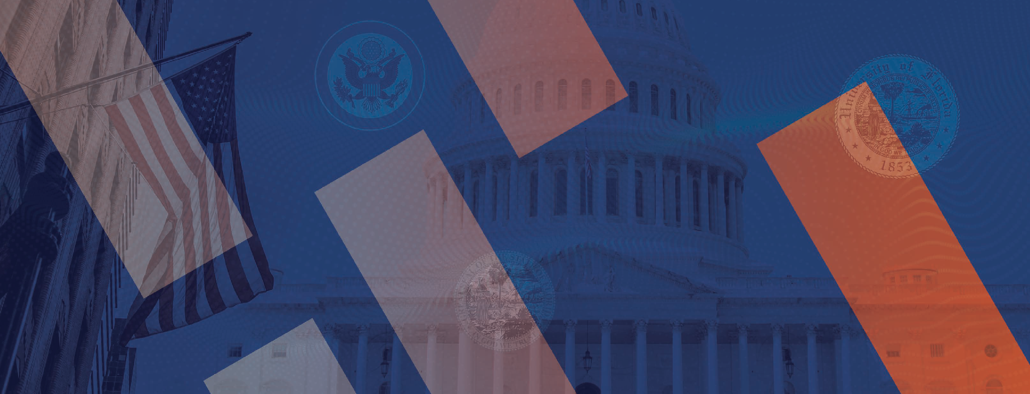
ARTIFICIAL INTELLIGENCE AT THE UNIVERSITY OF FLORIDA / 18 – 19

advancing industry across florida and beyond

Our Collective Future. Amplified.

“ Florida has long aspired to be home to our nation’s next technology hub. Through UF’s bold and innovative leadership, we are opening new doors that herald a new chapter of growth for Florida’s economy.”
– BOB WARD
PRESIDENT & CEO, FLORIDA COUNCIL OF 100
Our collaborative approach to pursuing AI and data science as a fundamental institutional pillar extends far beyond
the reaches of our campus and community. UF is actively reaching out to industry leaders across Florida and the nation to explore how our new initiative can help industry respond to their own unique challenges and emerging questions.

As UF positions itself to support industry in preparing for its own technological transformation, it is focused on seven distinct priorities:

- Building a curriculum that prepares students to apply AI and data science across every discipline, and graduating students that will bolster the workforce’s ability to harness these technologies.
- Creating recruitment opportunities for industry to connect with students and graduates who are experts in these fields.
- Creating opportunities within our infrastructure to highlight companies that partner with UF in support of these efforts.
- Creating internship opportunities within industry to give students real-world experience in applying AI and data science in the workplace.
- Enabling student-led projects to extend beyond campus and into industry to give companies access to new ideas and emerging technology.
- Applying AI and data science to industry challenges by creating consulting opportunities, as well as entrepreneurial engagement.
- Partnering with companies to give them access to UF’s supercomputing resources for their own needs.



ARTIFICIAL INTELLIGENCE AT THE UNIVERSITY OF FLORIDA / 20 – 21

applying ai across the uf curriculum

AI – Enabled. World Ready.

The ability to harness technology across a wide range of industries will in large part define the workforce preparedness of our students going forward. With this notion in mind, UF is committed to embedding AI and
data science across our curriculum - becoming the first university to apply these skills holistically in the academic enterprise.

With its AI Across the Curriculum initiative, UF is committed to offering all students, regardless of their course of study, the opportunity to acquire skills and expertise in AI and data science and to learn how these new technologies can be used in their major and chosen occupation.
This initiative is highlighted by the following:

- Giving students the opportunity to engage with AI and data science and obtain additional credentials, including a new certificate program, depending on the time and effort they wish to invest.
- Graduating thousands of AI-equipped students per year who will bring the benefits of AI and data science across many sectors of the economy.
- Building on UF’s new undergraduate major in data science, and pursuing graduate-level programs in applied data science and artificial intelligence.
- Launching an introductory course available to the entire university community entitled “Frontiers in AI.”
- Deploying our academic programs to other colleges and universities to affect the state and national economy at scale.

“ We believe that Florida can be a national leader with a replicable model to graduate an AI workforce at scale
at a particularly critical moment. Our curricular initiatives in this space will drive our success going forward.”
– PROVOST JOE GLOVER
UNIVERSITY OF FLORIDA

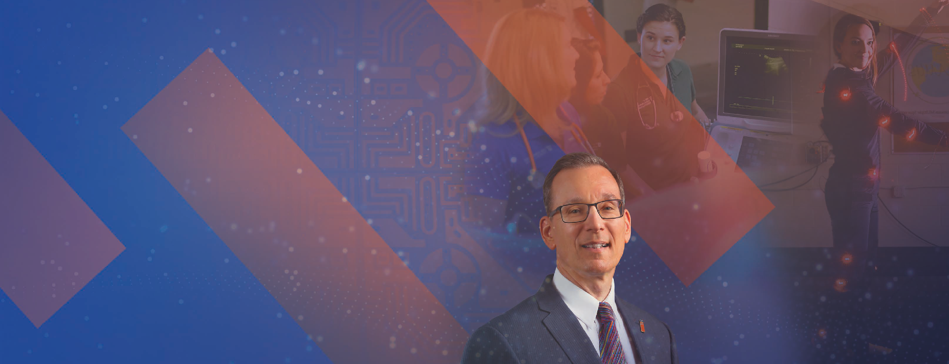
ARTIFICIAL INTELLIGENCE AT THE UNIVERSITY OF FLORIDA / 22 – 23

developing talent for tomorrow’ s jobs at scale

Workforce For Good

UF awards approximately 10,000 undergraduate, graduate, and professional degrees each year across a comprehensive range of academic disciplines. As our AI Across the Curriculum program matures, UF will graduate thousands of AI-enabled students ready to assimilate a robust set of technical AI and data science skills into the workplace on an annual basis, and across all employment sectors.

In pursuing this initiative, UF is emerging as the first university in the world to model a methodology that will produce a 21st century AI-enabled workforce at scale, thus responding to the call of our state and national leaders for ongoing workforce development across AI and data science sectors.

“ AI is a critical workforce tool, and I believe every student should graduate with some knowledge of the technology. It’s critically important this next generation understands how to use AI responsibly and is educated about its impacts and issues.”
– MAJ. NATHANIAL BASTIAN
CHIEF ARTIFICIAL INTELLIGENCE ARCHITECT,
U. S. DEPARTMENT OF DEFENSE


ARTIFICIAL INTELLIGENCE AT THE UNIVERSITY OF FLORIDA / 24 – 25

artificial intelligence at work

Amplified Leadership for Artificial Intelligence
UF has long been home to leaders in computer science, artificial intelligence, data science, and other technologies. Our preeminent teams of researchers and professors integrate these technologies into their programs and curriculums, enhancing the efficacy of their efforts to train a new generation of student-leaders while combating new and pressing societal challenges.

Through its AI Faculty 100 program, UF has committed to hiring 100 new faculty members, reflecting a diversity of backgrounds and experiences, across these technology-based disciplines. All colleges will participate in this hiring initiative.

Damon Woodard’s Big Vision for Biometrics and AI
Keeping pace with the changes and challenges of the 21st century is part of what drives Gators to Go Greater. Biometrics expert and proud Gator Damon Woodard helps lead the university’s charge in making the world safer and more secure through AI. His research explores the use of physiological and behavioral signals to establish a person’s identity.

Real-world applications of Woodard’s work enhance homeland security, law enforcement, and identity protection. Working with the CIA, FBI, the U.S. Department of Justice, and the U.S. military, among others, Woodard’s contributions to biometrics have helped
secure entrance to the nation’s borders, identify crime suspects, and prevent identity fraud. Bold and purposeful, Woodard is ready to help drive UF’s AI charge.

“ We’re on the precipice of extraordinary leaps in biometrics, all for the greater good. There’s never been a more exciting time to be at the University of Florida.”
– DR. DAMON WOODARD


ARTIFICIAL INTELLIGENCE AT THE UNIVERSITY OF FLORIDA / 26 – 27

uf’ s un paralleled i n frastructure is opening new doors

Processing Without Peer

Through UF’s AI and Data Science initiative, we are bringing unprecedented infrastructure to the academic setting.
From higher education’s most powerful AI supercomputer to a record-breaking new data science facility, our community will have access to the tools necessary to make a lasting impact.

Supercomputers for a New Age
Two powerful supercomputers form the processing backbone of UF’s efforts:

- HiPerGator 3.0 is UF’s general-purpose machine. Now in its third iteration since its launch in 2013, HiPerGator operates at 1 Petaflop or better, meaning it is capable of one quadrillion operations per second.
- HiPerGator AI is UF’s new AI-supercomputer, which is the most powerful machine of its kind in higher education. Acting in tandem with HiPerGator 3.0,
it is capable of operating at 0.7 Exaflops, or nearly one quintillion operations per second. HiPerGator AI is expected to be among the Top 25 fastest supercomputers in the world in 2021.

A New Icon on Campus
To accompany UF’s new supercomputing infrastructure, construction has begun on Malachowsky Hall for
Data Science and Information Technology. This signature facility will boast 260,000 square feet of multidisciplinary space housing programs in engineering, health care, and bioinformatics. The transformative building was made possible with significant support from the Florida Legislature, and from its namesake - alumnus Chris Malachowsky.

To match the power of what UF’s new supercomputing resources can achieve in one second, you would have to perform one calculation every second for over 31 billion years.

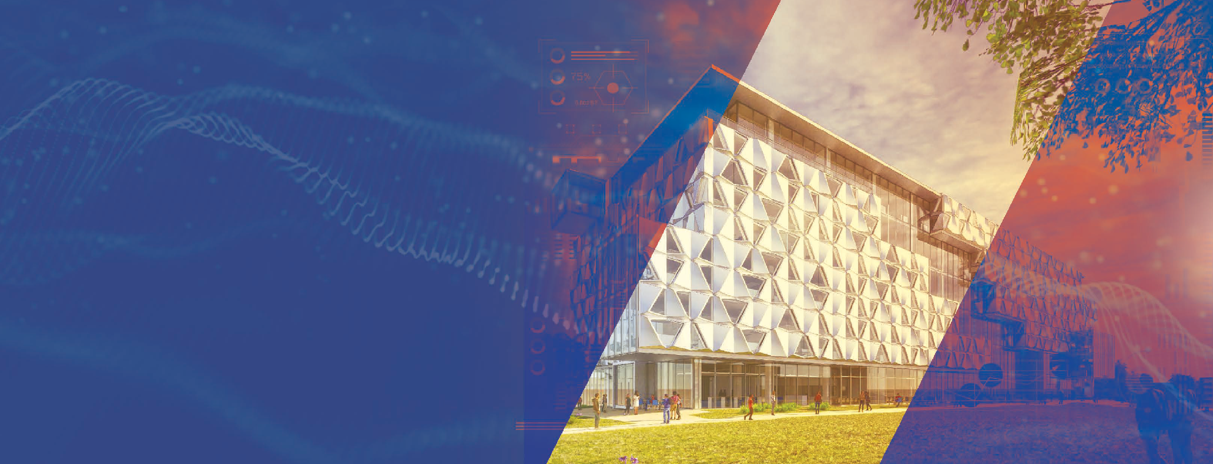
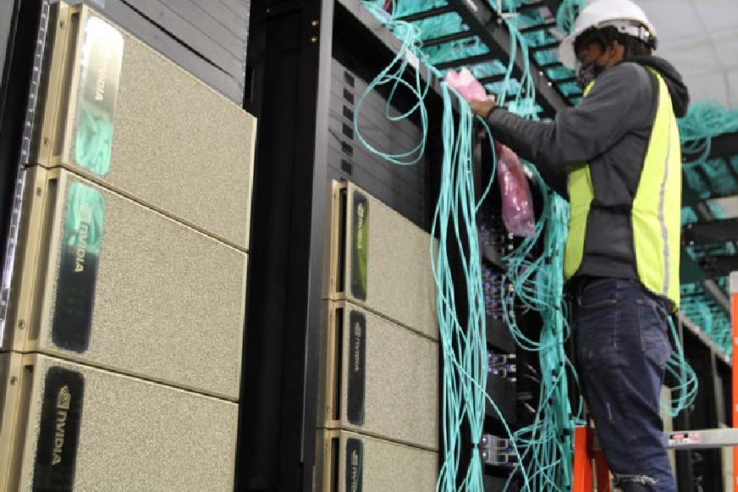
ARTIFICIAL INTELLIGENCE AT THE UNIVERSITY OF FLORIDA / 28 – 29

Democratized
Access

“ Advances in AI are crucial for the U.S. science and engineering enterprise, and nearly all sectors of our 21st century economy. Building the foundations of tomorrow’s AI innovations will require new interdisciplinary collaborations, resources, and strategic vision.”
– FLORIDA WORKFORCE 2030
FLORIDA CHAMBER OF COMMERCE

an offer to amplify our collective work

UF’s supercomputing infrastructure represents a significant leap forward, boasting exceptional capabilities. True to its founding mission as
a public institution, UF has made the bold decision to share these resources with those individuals and organizations that can use them to help advance the priorities of our state and nation. This access begins with other universities in the State University System, and will extend to universities across the nation and world with a specific emphasis on granting
access to universities serving underrepresented populations.

Robust Training & Support
To ensure that every individual who can use UF’s powerful infrastructure to make a lasting impact is able to do so, UF will partner with NVIDIA to create groundbreaking training programs that will teach these individuals how to leverage this technology for their own teaching, learning, and research needs. UF will also create innovative and flexible support structures to amplify our training productivity and to provide critical help as these individuals come online.


ARTIFICIAL INTELLIGENCE AT THE UNIVERSITY OF FLORIDA / 30 – 31

enhanci ng uf’ s research enterprise

Amplified Ingenuity

With a research expenditure portfolio already exceeding $900 million per year, UF’s research enterprise is among the nation’s most comprehensive and productive. As
our research faculty avail themselves of our new supercomputing infrastructure and aligned support systems, this technology will supercharge their efforts across every discipline.

To jump-start the adoption of this technology, an internal grant program was launched and has already awarded 20 faculty teams funding to pursue their AI and data science-related work. These projects will utilize the university’s exceptional computing capabilities to analyze vast amounts of data and predict solutions
to health, agriculture, engineering and educational challenges.

Artificial Intelligence Research Catalyst Fund Projects
Funded research pursuits include the following:

  - AI-driven movement analysis in the College of the Arts
  - Fairness in information access with AI systems in the College of Journalism and Communications
  - Machine Learning for drug optimization in the College of Pharmacy
  - AI to uncover global ecological change in the Florida Museum of Natural History
  - Real-time management of micromobility services for smart cities in the College of Engineering

“ With UF leading the way in AI research and education, Florida has an unparalleled opportunity to attract the best and brightest people and industries to our state.”
– DR. DAVID NORTON
VICE PRESIDENT FOR RESEARCH


ARTIFICIAL INTELLIGENCE AT THE UNIVERSITY OF FLORIDA / 32 – 33

artificial intelligence at work

AI in Agriculture

students lead the way

in supporting florida’ s growers
ON THE FARMS AND FIELDS ACROSS FLORIDA, NEW TECHNOLOGY IS BEING DEPLOYED TO HASTEN IN A REVOLUTION IN AGRICULTURE – DRIVEN IN PART BY A COLLABORATIVE COALITION OF UF STUDENTS.

“ We don’t understand the machine learning side, and they don’t understand the biology side, but when you’re looking at the same problem together, each side brings different viewpoints. That process is the key to making these advances. It has to be done together.”
– DR. DIANE ROWLAND
UF’ S AGRONOMY DEPARTMENT CHAIR
Drones, robotic arms, multispectral and thermal imaging, and new software are all being used to process and analyze everything from citrus orchards to row crops like tomatoes and blueberries while advancing science that will help our farmers make better decisions.

Working to help apply UF’s AI initiative across the work of UF/ IFAS, UF’s Agronomy department chair Diane Rowland brings a
collaborative group of engineering and agronomy students together to examine how technology can support agriculture work. Rowland’s work with students is part of a multi-disciplinary grant designed
to help boost crop yields with a more sustainable approach to the water, chemicals, and energy required for growth.

Their work will harness UF’s new supercomputing resources to process data and images at a faster rate, which in turn yields faster results. Their work is but one example of how UF is applying its
AI initiative statewide to revolutionize one of Florida’s primary industries.


ARTIFICIAL INTELLIGENCE AT THE UNIVERSITY OF FLORIDA / 34 – 35

Minds Before
Machines At UF, we have always driven progress by doing what we
were founded to do: bringing new knowledge and new

joi n us on our ai and

data science journey today
tools to bear against society’s evolving needs.

Today, we break new ground by harnessing the power of artificial intelligence and data science to amplify our ability to impact the people and communities we serve.

This work is never done in isolation. Our AI ecosystem demands collaboration - from our students, staff, researchers, health care providers, elected leaders, alumni, community members, and friends.

This is our time. Together, we can catalyze a future that is data based, but human inspired. Join us today.

To learn more about UF’s AI and Data Science initiative, please visit ai.ufl.edu.

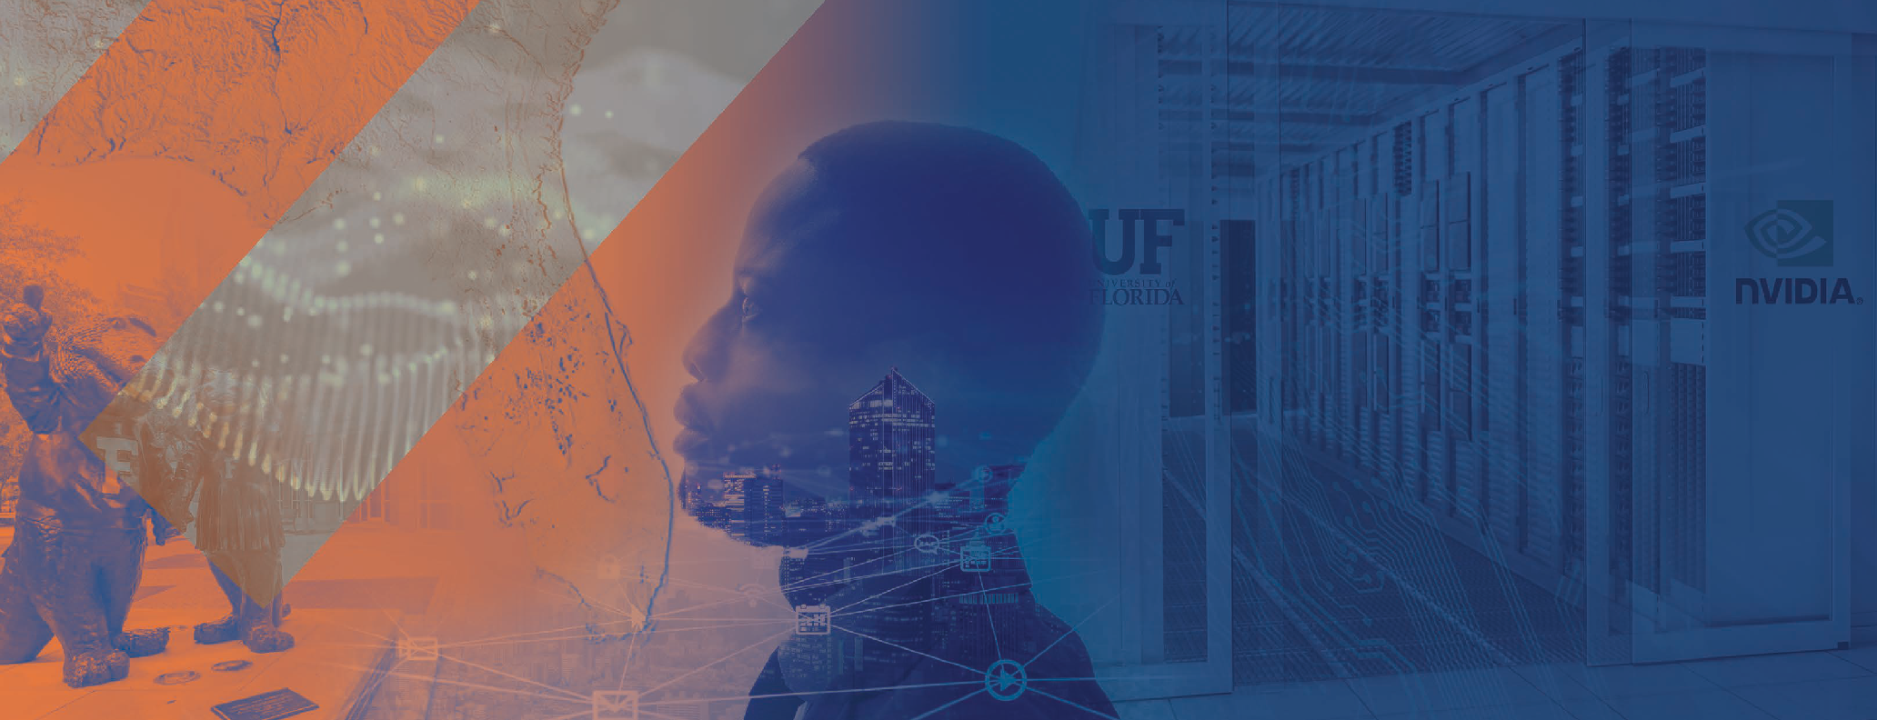
ARTIFICIAL INTELLIGENCE AT THE UNIVERSITY OF FLORIDA / 36 – 37

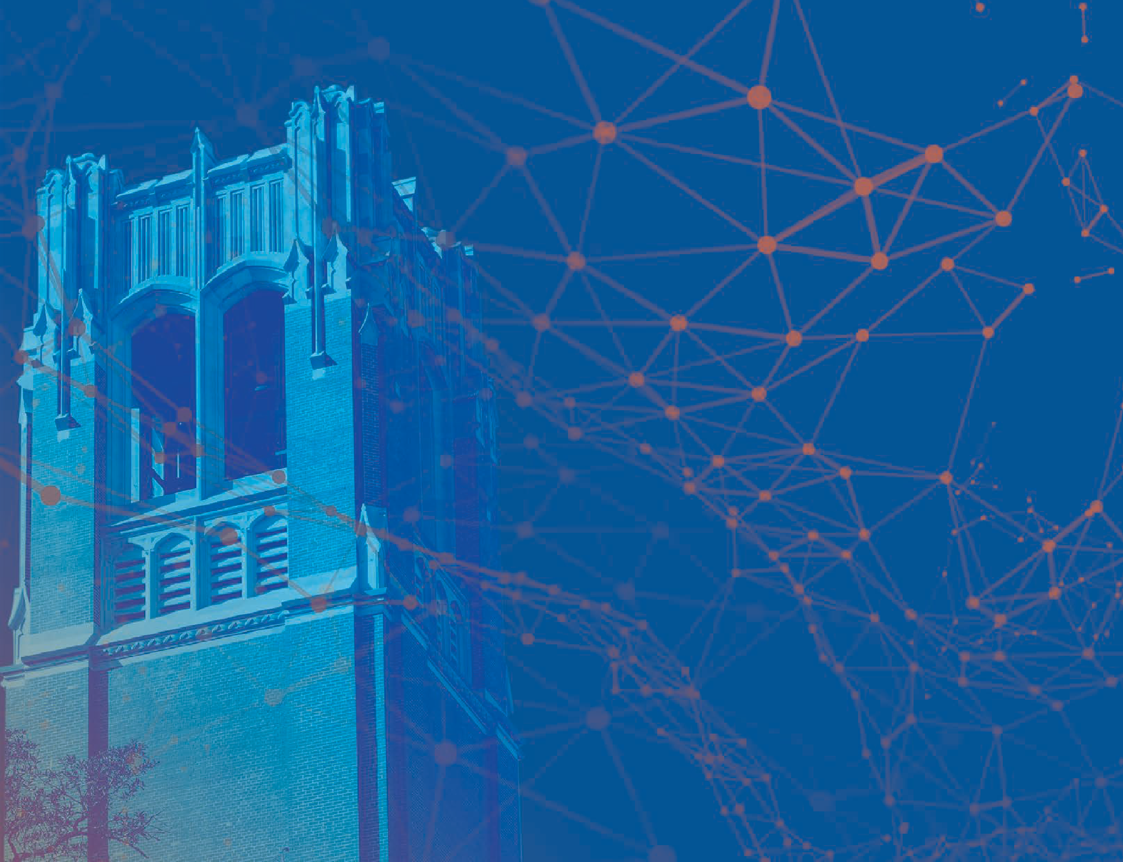


To learn more about UF’s AI and Data Science initiative, please visit ai.ufl.edu.

