BUILDING THE NATION’S FIRST AI UNIVERSITY

TABLE OF CONTENTS
Building an AI University 3
AI Across the Curriculum 4
Certificates in AI 7
AI Professional Development 8
AI for Florida’s K-12 11
State and National Partnerships 12
The AI2 Center 14

Listen to this podcast about UF’s efforts to build an AI University, featuring Joe Glover, provost and senior vice president of academic affairs.

Artificial intelligence has become the talk of the day, as it transforms the way we live and work. We use AI in our daily lives, from asking Siri for directions, to getting Netflix movie recommendations or having facial recognition to open our smart phones. Artificial intelligence holds tremendous promise for innovation, equity, and ingenious solutions if we can prepare America’s workforce at speed and scale to embrace and harness this new technology.
The need for a skilled AI workforce grows daily as large and small companies look to understand large data sets to gain a competitive edge. Forbes predicts that the workforce demand is projected to grow to
$190 billion by 2025.
The state of Florida is a leader in AI education. Centered at the land-grant University of Florida, faculty have been educating students in AI across all 16 of its colleges as well as working with the Florida Department of Education to establish an AI framework for K-12. In addition, the University of Florida has partnered with Florida HBCUs and state colleges
to train their faculty and increase their AI offerings across each campus. This highly coordinated effort of

Building an AI University

AI learning in K-20 plus professional development is unique in the United States, therefore the University of Florida is well prepared with the tools to educate the digital workers of tomorrow to further strengthen our nation’s economy and national security.
UF’s comprehensive AI research is supported with HiPerGator, one of the fastest supercomputers in higher education, gifted to UF by the NVIDIA Corp. This resource is available to all faculty and students, as well as to other universities and industries.

In 2022, the university established centralized leadership of AI academic efforts via the establishment of the Artificial Intelligence Academic Initiative (AI2) Center.
This booklet details UF’s journey in building the Nation’s First AI University.

UF is transforming the nation’s
AI-enabled workforce by graduating thousands of knowledgeable and trained students to bring these technologies into the workforce.




3
2

UF 27

Artificial Intelligence Across the Curriculum

Teaching artificial intelligence broadly across all disciplines is the foundation for Building an AI University. By doing so, a larger and more diverse group of students will graduate UF with AI knowledge.
The goal of AI Across the Curriculum is the creation of an interdisciplinary AI-ready workforce as well as
preparing our students for the jobs of the future, many of which will require AI knowledge.
The university became committed to building the nation’s first AI university by infusing AI instruction in all disciplines, hiring more than 100 expert AI
faculty across our 16 colleges, and offering more than 200 courses in AI and data science to thousands of students. At UF, we offer AI courses to any student regardless of their major because AI technology is being used in so many disciplines. Students with no prior education in computer or data science can learn the fundamentals of AI as well as AI ethics.
The foundation for UF’s success in AI Across the Curriculum is a university-wide, nine-credit hour
certificate in artificial intelligence. The certificate consists of three courses: Fundamentals of AI; Ethics, Data and Technology; and a third course contextualizing AI and data science within the student’s chosen major. Students who would like to obtain greater competence and expertise can add additional coursework in artificial intelligence and applications within their major field of study.

UF recognizes artificial intelligence as more than just an add-on skill in a discipline. With AI permeating
all aspects of our lives, the University of Florida is embracing this Amplified Intelligence in the operations of the entire campus, as well as in its research, teaching and outreach missions. The university is positioned to be a national model in its multi-faceted approach that will graduate thousands of students with artificial intelligence knowledge who are prepared
to work in the 21st century. This will greatly impact
the AI workforce needs that are of national and global concern.

Students with no prior education in

AI INFLUENCE ON THE UF CAMPUS

HiPerGator
computer or data science can learn the fundamentals of AI as well



16
colleges
4

230
courses
5

7.5K
students
fastest computer in higher ed available for student use

as AI ethics.

AI learning helps to form critical thinking skills, data analysis and interpretation, problem solving, and the ability to apply skills in the real world.

Certificate Programs in Artificial Intelligence

Learn more about UF’s certificate programs in artificial intelligence.
There is a workforce shortage in the field of artificial intelligence; therefore, obtaining AI skills can provide a promising career in many disciplines. The
University of Florida’s university-wide certificate is for undergraduates of all majors (both technical and non-technical) to understand the fundamentals of artificial intelligence, its applications to real-world problems
in various disciplines, and ethical and professional responsibilities of these technologies. Hundreds of students are taking advantage of this certificate now.
ADDITIONAL AI CERTIFICATES
While the above undergraduate certificate is offered to any student in any major, individual UF colleges are creating their own certificates to meet the distinct needs of their students. For example, the College of Health and Human Performance offers an AI Certificate in Tourism, Hospitality and Events Management, and the College of Liberal Arts and Sciences offers a certificate in Geographic AI.

UF’s Career Connections Center has
an AI-specific career coach to help students find internships and employment with companies that utilize artificial intelligence.
GRADUATE COURSES, CERTIFICATES & DEGREES
UF offers a myriad of courses at the graduate and professional levels wholly focused on AI and Data Science. There are two graduate certificates available within the colleges of health and human performance, and journalism and communications, and a master’s degree in information systems and information management within the Warrington College of Business. Many more AI graduate certificates and degree programs are in the approval stages.
A certificate in AI, available to all students, can complement any major and
be stacked with other certificates or a minor.
ENSURING STUDENT SUCCESS IN AI
Not only does UF have an AI-teaching commitment to all students, but it also wants to ensure their success upon graduation. Students can analyze vast amounts of data and predict solutions that can impact our country’s biggest challenges with HiPerGator, one
of the fastest computers in the world. In addition, UF offers AI expertise in its nationally ranked Career Connections Center to counsel students on AI courses, internships, career opportunities, as well as having the ability to build industry partnerships with
those seeking AI talent.
6


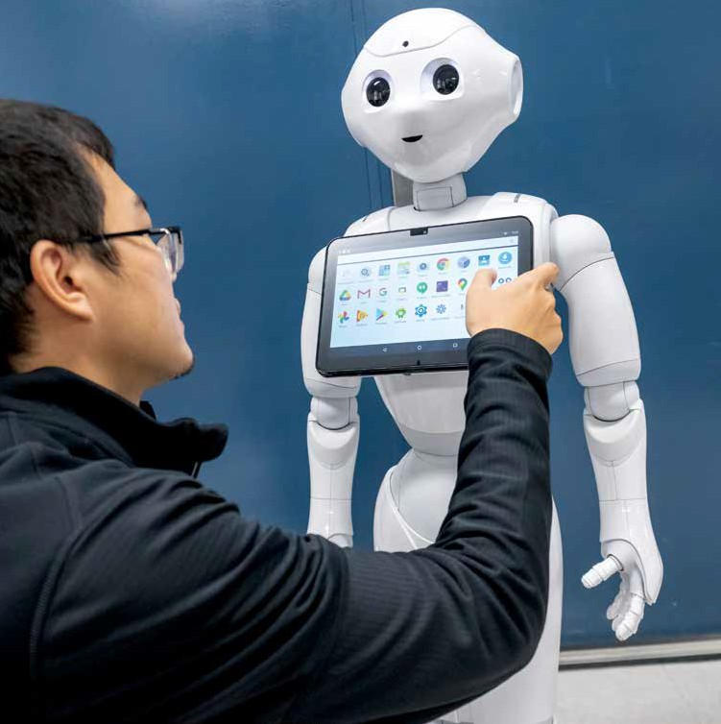

7

AI Professional Development

UF is responding to the call of our state and national
leaders for ongoing workforce development across AI and data science sectors.

Artificial intelligence is more than just the next wave of high-tech — it’s transforming nearly every sector of the economy. Every industry is clamoring for
AI talent, so seeking additional education is a wise investment for individuals and companies that wish to remain competitive.
Those already in the workforce can increase their knowledge of artificial intelligence through professional development courses offered by the University of Florida Office of Professional and
Workforce Development. Those who wish to pursue knowledge in AI can enroll in UF’s flexible, online program designed for working professionals to learn the latest in AI-driven practice and techniques for advancement of careers. No technical knowledge
is necessary, as these courses start from the basic
has two foundational courses that focus on the fundamentals of AI and AI Ethics. These provide learners with a familiarity of artificial intelligence and its broad applications. Further courses hone in on the application of AI in certain disciplines, including agricultural and life sciences, applied data science, business, and engineering. UF’s professional development courses are open to individuals as well as businesses that want to upskill their employees.
Each of these courses offers a one-hour introduction for free.
THE JOB FUTURE FOR AI SKILLS: EXTREMELY PROMISING

fundamentals of AI.
Some people in the workforce may only need a passing familiarity with AI, whereas others may need to learn how to apply AI in their field. UF

Learn more about
UF’s microcredential program offered by the Office of
325,193
National Job Postings
9,666
Florida Job Postings
94%
business leaders in
2022 surveyed believe AI is critical to success, according to Deloitte
$92,200
National Median Salary
$80,300
Florida Median Salary
77%
of businesses are using
or exploring the use of artificial intelligence, according to IBM




Professional and Workforce Development at UF.
9
8
Forbes predicts that the AI workforce demand is projected to grow to $190 billion by 2025.

Bringing AI Learning to Florida’s K-12

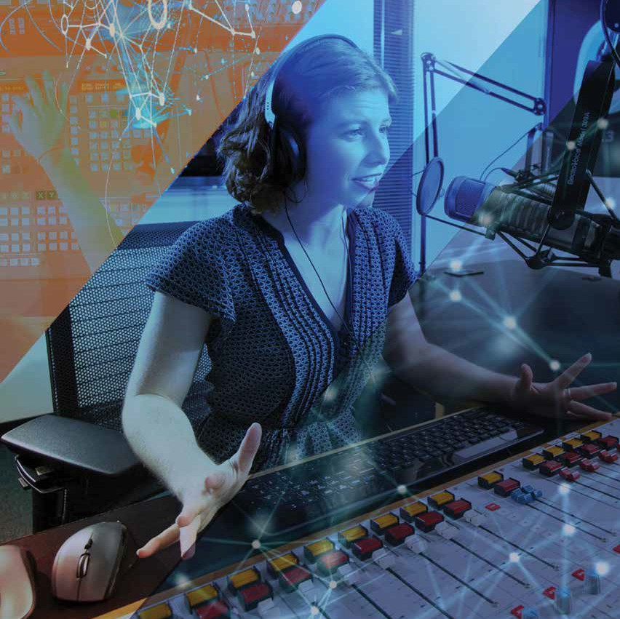


UF’s inclusive and comprehensive model to educate K-12 teachers can serve as a model for any school district in the nation.
Florida is among the first states to adopt a K-12 artificial intelligence education program designed to prepare its youth for the growing global demand for an AI-enabled workforce. Educators are the key to preparing students to thrive in a world where artificial intelligence is an integral part of their lives and careers. UF faculty from the Herbert Wertheim College of Engineering and the College of Education have been at the helm of designing the framework for the Florida public schools’ AI coursework, modeling it after the National Science Foundation’s national guidelines for teaching AI in elementary and secondary schools. The goal is to increase students’ knowledge of AI and their awareness of how AI is used in their everyday lives.
With artificial intelligence ubiquitous in our everyday lives, it is essential to make AI learning accessible to K-12 students.
Our nation is just beginning to think about how to introduce AI to K-12 students, many of whom
interact with the technology through AI-interfaced toys, smart phones, Alexa and Siri. In May 2018, the Association for the Advancement of Artificial Intelligence (AAAI) and the Computer Science
Teachers Association (CSTA) formed a joint working group to develop national guidelines for teaching
K-12 students about artificial intelligence. Inspired by CSTA’s national standards for K-12 computing
10
education, the AI for K-12 guidelines would define what students in each grade should know about artificial intelligence, machine learning, and robotics. The AI4K12 initiative, founded and chaired by a UF researcher, is developing national guidelines for
AI education, creating an online, curated resource directory of AI teaching tools, as well as building a community of collaboration between practitioners, researchers and tool developers.
ESTABLISHING AN AI FRAMEWORK
UF is establishing a broad and long path of AI learning opportunities for K-12 students by first establishing the framework for the learning standards for AI courses to be taught in Florida’s K-12 classrooms.
This includes:
› Specifying course descriptions, learning standards and benchmarks
› Ensuring that state learning standards are met, especially in computer science
› Outlining courses that a student needs to earn a certificate or credential
› Establishing the standards for K-12 teachers to meet Florida Department of Education (FDOE) certification to teach AI, including providing guidance on lesson plans and instructional resources

11

Strengthening AI Resources in our State and Nation

UF is giving access to educational training and support programs and supercomputing resources to other universities across the state and nation to ensure the democratization of these

The University of Florida is committed to leveraging its artificial intelligence knowledge and resources by partnering with other institutions, thereby reaching far more people and having a greater
impact than it could alone. UF’s partnerships include other institutions of higher learning, primary and secondary schools, and private-sector organizations.

UF AND FLORIDA A & M UNIVERSITY
These universities were awarded a $1.4 million, three-year National Science Foundation (NSF) grant to help develop careers in artificial intelligence. The goal is to bring resources previously unavailable
to Florida A&M students and ensure that a diverse AI-enabled workforce will be of varied interests, backgrounds, experiences, and races in the development, deployment, and evaluation of AI systems.

UF AND MIAMI DADE COLLEGE
Through a $1 million NSF grant awarded to Miami Dade College, UF faculty are collaborating with Miami Dade to create courses and integrate AI into their curriculum. Miami Dade, which has the country’s largest enrollment of Hispanic/Latinx students, now offers a college-credit certificate in
artificial intelligence as a result of this collaboration.
PALM BEACH STATE COLLEGE AND SANTA FE COLLEGE
UF and Palm Beach State College received $1 million in federal funding to educate PBSC faculty in AI and create new course content for their students for high-tech jobs. Discussions have begun regarding bringing AI learning to Gainesville’s Santa Fe College.

FLORIDA’S PUBLIC SCHOOL DISTRICTS
UF’s faculty in engineering and education are working with Orange, Osceola and Broward counties’ public school districts to pilot an AI curriculum formulated
by these two colleges at UF as part of the AI4K12 initiative. Two of these districts are the largest in Florida, with this outreach impacting more than 500,000 school students. UF is educating the teachers in these districts on course descriptions, learning standards and benchmarks for these K-12 learners.

THE SOUTHEASTERN CONFERENCE
The Southeastern (Athletic) Conference, SEC, has created an AI Consortium of the 14 SEC universities. UF has played a leading role in the Consortium and hosted the first SEC AI Symposium in 2022. This collaboration shares educational resources, promotes faculty and staff development, and seeks joint partnerships with industry.

technologies while maximizing our ability to produce an AI-enabled workforce.

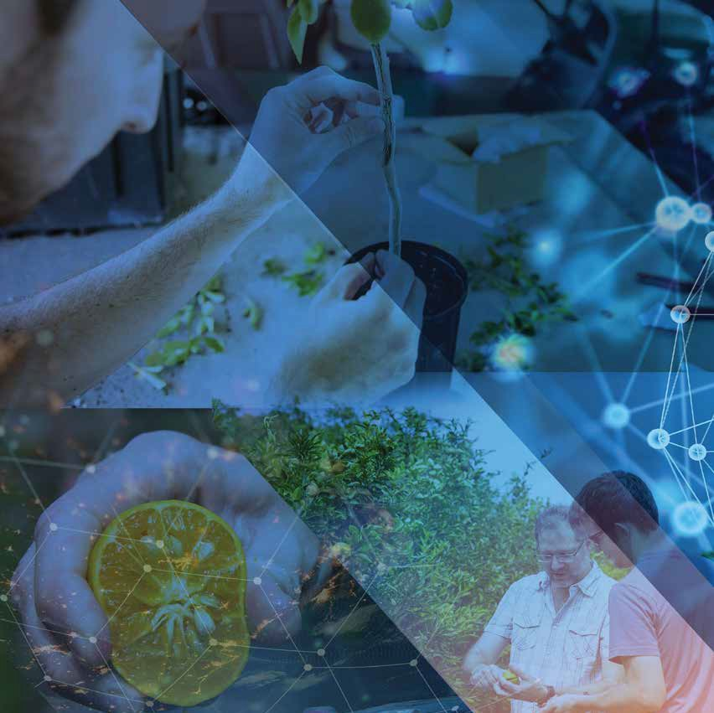
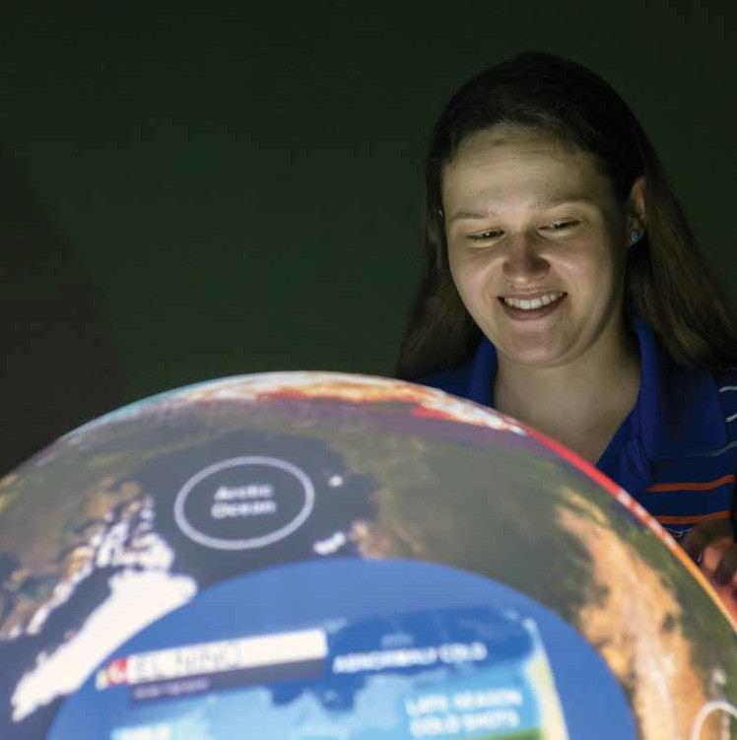
In collaboration with Orange County (FL) Public
Schools, the University of Florida is proposing a professional development model to up-skill and support teachers who will be implementing the AI Foundations CTE framework that has been submitted to the Florida Department of Education.
12
13

Artificial Intelligence Academic Initiative Center (AI²)

Let’s Connect!
Send us an email:

UF’s Artificial Intelligence Academic




The Artificial Intelligence Academic Initiative Center, known as AI2 (AI squared), is the UF focal point for academic initiatives related to AI and data science. The center coordinates the development of AI academic programs and certificates, identifies opportunities for faculty and students to engage with AI, organizes seminars and conferences, and collaborates with UF’s Career Connections Center, Florida’s colleges and universities, and private industry to train an AI-ready workforce that will contribute to our nation’s economy and security.
The center is also a guiding force in the university’s re-accreditation process and its five-year comprehensive work plan as it pertains to AI Across the Curriculum. This plan will address AI curriculum
development, academic programs and pathways to AI learning, AI student scholars and their research, and AI professional pathways and career readiness.

MISSION
The University of Florida is building the nation’s first AI university, and the AI2 Center’s mission is to support and enhance equitable and ethical AI
learning at the university, state and national levels.

14
GOALS
› Raise awareness of AI to internal and external audiences
› Develop AI Across the Curriculum to serve UF broadly
› Ensure widespread access to AI education for diverse audiences
› Develop a community around AI to facilitate learning and collaboration
› Create experiential learning opportunities to prepare students for entry into the AI workforce
› Expand UF’s model of AI education and workforce development nationally
› Oversee UF’s Quality Enhancement Plan titled AI Across the Curriculum for university re-accreditation

Universities that support students with a robust AI education can expect an alumni network filled with successful professionals across an array of industries.
ai@ufl.edu

Review our website for more in depth information, AI resources and news: https://ai.ufl.edu

Learn about upcoming AI events: https://ai.ufl.edu/calendar

Initiative (AI2) Center Staff

David L. Reed, Ph.D. Associate Provost for Strategic Initiatives and
Inaugural Director dlreed@ufl.edu 352-273-0987

Mackenzie Donovan Project Manager mackenzie.donovan@aa.ufl.edu
352-294-2748

Renee Buchanan Associate Director, Communications and Marketing
rbuch@ufl.edu 352-273-1267

Kimberley McCall Mughal Administrative Specialist II
kimccall@ufl.edu 352-294-1895

Maya James Assistant Director for Career Pathways, AI
Career Connections Center
Mjames1@ufl.edu 352-273-2334
15

Al2 CENTER

UNIVERSITY OF FLORIDA

P. O. Box 113175
ai.ufl.edu
324 Tigert Hall University of Florida Gainesville, FL 32611
352-294-1895
ai@ufl.edu

