BUILDING AN AI UNIVERSITY

ARTIFICIAL INTELLIGENCE ACROSS THE UF CURRICULUM
AI ACROSS THE CURRICULUM: OPPORTUNITIES FOR ALL STUDENTS
Artificial intelligence is the engine driving the 4th industrial revolution. Businesses large and small are using AI to power an ever-changing economy, and they need workers who understand AI across all sectors of employment. The demand for AI talent is increasing dramatically and the nation must work quickly to meet this demand. Traditionally, AI talent has come from colleges of engineering or schools of computer science, however their education is quite narrow in focus. To meet the needs of a changing workforce, we must produce talent from many disciplines who are also proficient in their understanding, and application of AI in their discipline. At the University of Florida, we have met the challenge of producing America’s AI-enabled workforce through a program we call “AI Across the Curriculum.”

FOUNDATION AND DISCIPLINE-SPECIFIC COURSES
At UF, we have made the fundamentals of AI available to any student regardless of their major through
AI Across the Curriculum. Students with no prior education in computer or data science can learn the fundamentals of AI as well as AI ethics. These foundation courses can then be supplemented with discipline-specific courses as the student learns how to apply AI in their field of study. This initiative
began in 2020 when UF was gifted one of the fastest supercomputers in the world and was positioned to be a pioneer in addressing the federal government’s need for more educated workers in artificial intelligence.
The university became committed to building the nation’s first AI university by infusing AI instruction in all disciplines, hiring more than 100 expert AI
faculty across our 16 colleges, and offering more than 200 courses in AI and data science to thousands of students.

Dr. Kevin Wang and Dr. Dana Choi use robotics in their plant research at UF’s Gulf Coast Research and Education Center.

AI WORKFORCE FOR THE 21st CENTURY
UF recognizes artificial intelligence as more than just an add-on skill in a discipline. With AI permeating all
aspects of our lives, the University of Florida is embracing this Amplified Intelligence in the operations of the
entire campus, as well as in its research, teaching and outreach missions. The university is positioned to be a national model in its multi-faceted approach that will graduate thousands of students with artificial intelligence
knowledge who are prepared to work in the 21st century.
This will greatly impact the AI workforce needs that are of national and global concern.

more info
AI’s Influence on the UF Campus
our positioning to be a national model
16 230 7.5K
colleges courses students

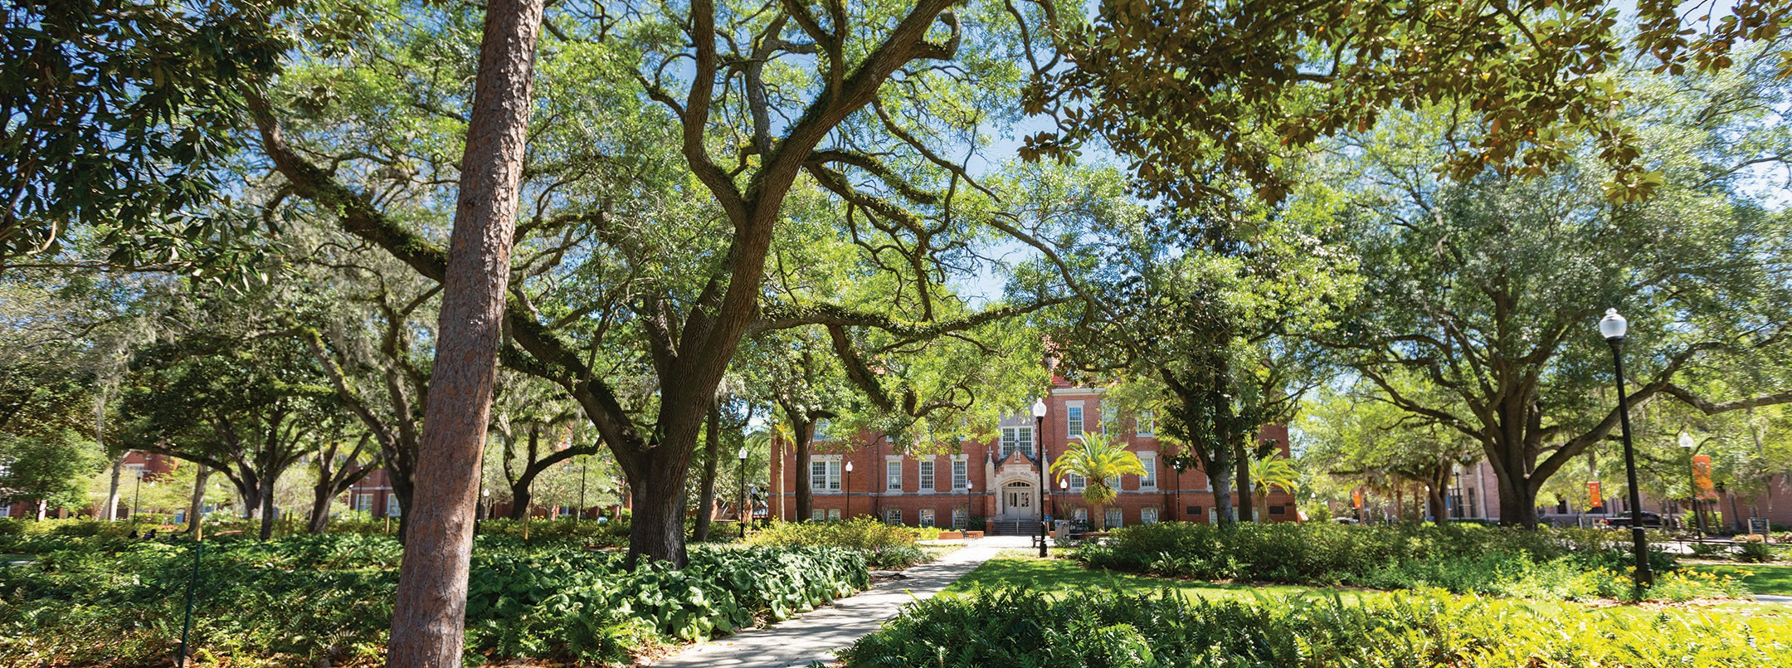
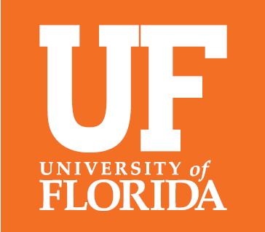

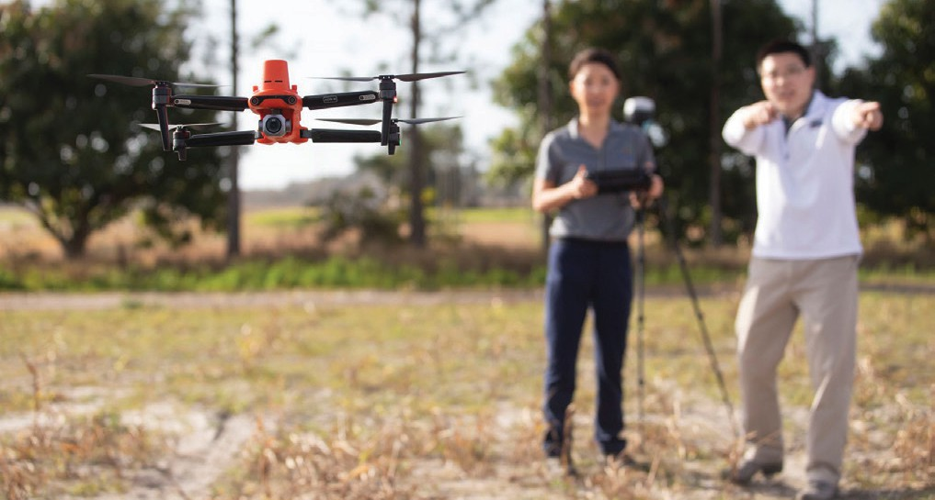
BUILDING AN AI UNIVERSITY
UNIVERSITY OF FLORIDA
AI ACROSS THE CURRICULUM
Current as of January 2023

ARTIFICIAL INTELLIGENCE CERTIFICATE PROGRAM
The foundation for UF’s success in AI Across the Curriculum began as a university-wide, nine-credit hour certificate in artificial intelligence. The certificate consists of three courses: Fundamentals
of AI; Ethics, Data and Technology; and a third course contextualizing AI and data science within the student’s chosen major. Students who would like to obtain greater competence and expertise can add additional coursework in machine learning and applications within their major field of study.
Fundamentals of AI: This course begins with the basics and history of AI and ends with a class project demonstrating the influence of AI in the world. The course is taught by the Department of Engineering Education in the Herbert Wertheim College of Engineering, but is designed for any undergraduate student at the university.

Ethics, Data and Technology: This course teaches students about bias, ethics, and making AI equitable, all fundamentals in the appropriate use of artificial intelligence. It is taught by the Department of Philosophy in the College of Liberal Arts and Sciences.

Courses within the major: These courses, taught within various UF colleges, teach students how artificial intelligence is impacting their field of study. Topics range from AI in Agricultural and Life Sciences, AI in Social Sciences, AI in the Built Environment, AI in Media and Society, and more.

Dr. Tina Tallon in the College of the Arts discusses with a student how artificial intelligence influences how artists engage with society.

ADDITIONAL AI CERTIFICATES
While the above certificate is offered to any student in any major, individual colleges are creating their own certificates to meet the distinct needs of their students. For example, the College of Health and
Human Performance offers an AI Certificate in Tourism, Hospitality and Events Management, and the College of Liberal Arts and Sciences offers a certificate in Geographic AI.

A ONE-CREDIT ELECTIVE IN ARTIFICIAL INTELLIGENCE
Frontiers of AI: This one-credit elective covers the basics of artificial intelligence and features guest lecturers who bring their expertise in AI in their discipline to the classroom. This elective is available to all students.

MANY ENTRY POINTS FOR AI LEARNING
UF is ensuring that every student has a variety of entry points to learn and grow skills in AI. UF encompasses 16 colleges, and many are incorporating AI learning
in various majors. Educating students within their major allows for faster and deeper learning due to the
students’ familiarity with the terminology and context of their discipline.

Faculty and students in UF’s College of Design, Construction and Planning are programming large robotics for construction framing, equating to cost savings in the building industry.

GRADUATE COURSES, CERTIFICATES & DEGREES
UF offers a myriad of courses at the graduate and professional levels wholly focused on AI and Data Science. There are two graduate certificates available within the colleges of health and human performance, and journalism and communications, and a master’s degree in information systems and information management within the Warrington College of Business. More than 10 more AI graduate certificates and degree programs are in the approval stages.

ENSURING STUDENT SUCCESS IN AI
Not only does UF have an AI-teaching commitment to all students, but it also wants to ensure their success upon graduation. Students can analyze vast amounts of data and predict solutions that can impact our
country’s biggest challenges with HiPerGator, one of the smartest computers in the world. In addition, UF offers AI expertise in its nationally ranked Career Connections Center to counsel students on AI courses, internships, career opportunities, as well as having the ability to build industry partnerships with those seeking AI talent.

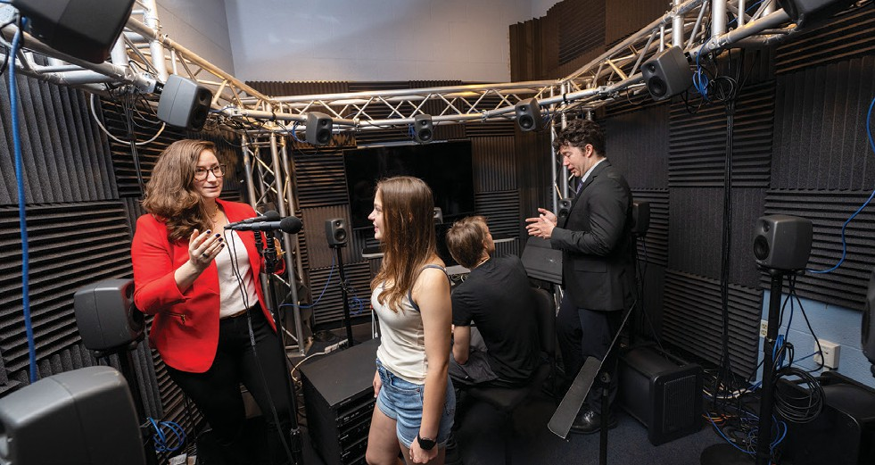
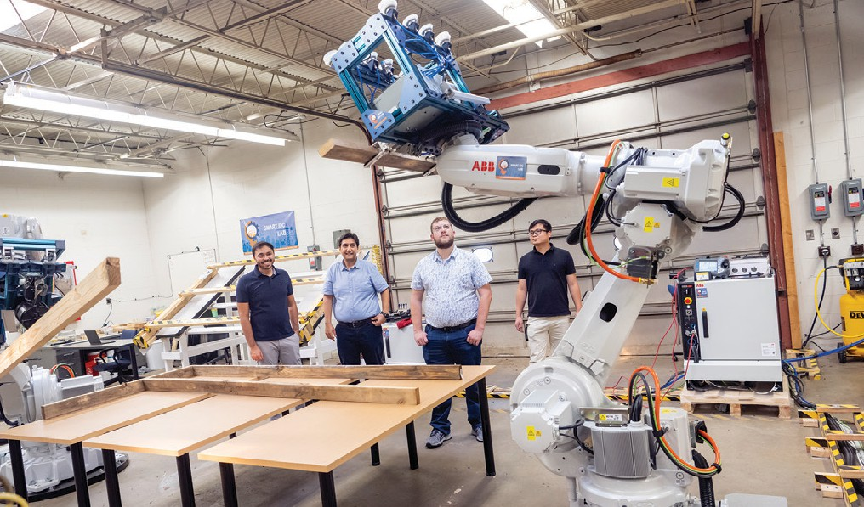

UF offers artificial intelligence career preparation to students through its nationally ranked Career Connections Center.
UF is home to HiPerGator, one of the fastest and smartest supercomputers in the world, accessed by faculty, students and our educational and industry partners.

