AI Across the Curriculum: Governance, Taxonomy, and Institutional Strategy
By Brittany Wise
12/05/2025
As artificial intelligence continues to transform industries, research, and everyday life, universities face a pressing challenge: ensuring that graduates from every discipline possess meaningful AI literacy. Recognizing this, the University of Florida (UF) in 2020 launched the AI Across the Curriculum initiative, a university-wide effort to embed AI knowledge and skills throughout undergraduate, graduate and professional programs. By adopting this initiative as the Quality Enhancement Plan (QEP) through its accreditor, UF reinforced its commitment, formalized governance structures, and aligned resources to create a sustainable, institution wide framework. The initiative provides a model for other universities seeking to prepare students for an AI-driven world while supporting faculty in integrating AI into diverse disciplines.
Building a Vision for AI Across the Curriculum
UF’s initiative begins with a clear, strategic vision: all students should graduate with meaningful AI literacy, faculty should be empowered to integrate AI concepts into their disciplines, and the curriculum should foster ethical, technical, and creative competence. To achieve this, an AI workgroup that met over the period of a year defined core AI competencies that serve as the backbone of all courses and programming and provide the foundation for course design, curriculum development, and assessment of student learning outcomes across academic programs:
● AI-Enabled: Supports AI literacy through related content or foundational skills, even if they contain limited AI infrastructure.
● Know & Understand AI: Know the basic functions of AI and its applications. ● Use & Apply AI: Apply AI knowledge, concepts, and tools effectively in varied contexts.
● Evaluate & Create AI: Engage in higher order thinking skills (e.g., evaluation, prediction, design) with AI applications.
● AI Ethics: Develop and apply ethical framework for responsible AI use.
Defining these competencies at the outset ensures that course design, assessment, and faculty training remain aligned with institutional priorities, creating clarity for students and instructors alike. All categories require at least 50% AI content except the AI-Enabled designation, which
was developed to recognize courses that boost AI literacy even if concepts make up a minority of the course content.
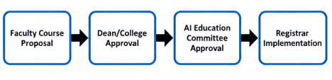This graphic captures the journey of an AI course from faculty origins through implementation.
How-To Takeaway: Begin by defining a clear institutional vision for AI literacy and adopting a shared set of core competencies that all AI-related courses must align to. These competencies become the backbone for course development, faculty training, and assessment, ensuring consistency and scalability as the curriculum grows.
Creating the Structure: The Role of the AI² Center
Central coordination is key to scalability. UF established the AI² Center as a university-wide hub, independent of any single college or department, to ensure impartiality, foster collaboration, and support consistent progress across disciplines. The Center serves as both an administrative and intellectual home for UF’s AI initiative, coordinating development of academic programs and
certificates, identifying opportunities for faculty and students to engage with AI, and working with UF’s Center for Teaching Excellence to manage the university’s AI Learning Academy, which offers professional development courses for faculty and administrators. It also organizes seminars and conferences, shares teaching resources, and builds partnerships with UF’s Career Connections Center, Florida’s colleges and universities, SEC peers, and private industry.
Led by a director and comprised of a staff of eight people, the Center operates on an annual budget of $1.2 million plus a $800,000 time-limited stipend for the AI Learning Academy. Although knowledge of AI is a bonus, the most important quality for a director is someone who can bring together people from around the institution. Other positions within the center include an associate director of operations, programs and initiatives; an associate director of communications and marketing; a marketing and communications specialist; an administrative specialist; an assistant director for AI student engagement and experiential learning; an AI learning and organizational development specialist and a project manager.
Funding comes from an institutional commitment that guarantees all colleges have equal access to support for course and program development. The Center’s interdisciplinary staff provide faculty development, course review, data tracking, and reporting. They also oversee the university’s Quality Enhancement Plan, a cornerstone of UF’s accreditation, and coordinate with
the AI Education Committee and university leadership to align course designations and resource allocations with institutional priorities. The AI Education Committee, made up of volunteer faculty, includes a member of each college that offers significant curriculum and is tasked only with reviewing course designations, and not course approvals. By centralizing these functions, the AI² Center minimizes duplication, standardizes practices, and sustains momentum across the university.
How-To Takeaway: Create a centralized, university-level hub that coordinates all AI academic activity, such as course designation, faculty development, program building, data tracking, and partnerships. Staff it with interdisciplinary experts and ensure stable institutional funding so every college has equal access to resources. This structure avoids duplication, maintains consistent standards, and keeps momentum across departments.
Governance
Governance of AI Across the Curriculum is shared across several coordinated bodies. The AI Education Committee, composed of ad-hoc faculty representatives from each college, reviews courses seeking AI designation, validates alignment with the core competencies and taxonomy, and ensures consistency and quality across disciplines. College faculty retain authority over course creation and discipline-specific curriculum decisions, including identifying faculty to develop AI content and guiding proposals through college-level review. University leadership provides final approval for courses and ensures alignment with institutional priorities. This shared structure balances centralized coordination with distributed academic ownership, enabling both consistency and innovation across the university.
How-To Takeaway: Build a shared governance model that balances centralized standards with college-level ownership. Empower a cross-college faculty committee to validate AI course designations and ensure institutional alignment while letting colleges lead discipline-specific curriculum development. This structure maintains quality and coherence while allowing innovation across academic units.
Designing the Curriculum Framework
At the heart of UF’s model is a thoughtfully constructed course taxonomy that balances consistency with flexibility. Each course is mapped to one or more of the core competencies, enabling transparent reporting and supporting institutional assessment goals.
A faculty member proposing a course follows a structured process: a draft proposal is reviewed at the college level and approved by the dean, submitted to the AI Education Committee for validation and assignment to a taxonomy category, and finally implemented by the university registrar. All AI designated courses must address at least one competency and, with the exception of the courses labeled Enable-AI, at least one Student Learning Outcome (SLO) for that literacy, as defined below.
Faculty can develop AI-related courses on their own, but to have a course formally recognized as part of the university’s AI initiative, it must go through a review process managed by the AI Education Committee within the AI² Center. This process ensures that each course aligns with
the appropriate SLOs for its designated AI literacy category and that AI content is meaningfully integrated into the syllabus. Once approved, the course receives a tag in the catalog, raising the visibility for students who want offerings that match their interests and career goals. Courses that are not tagged can’t be searched by literacy type. The AI Education Committee plays an important role in maintaining quality and consistency across designations, reviewing syllabi to confirm alignment and depth of AI content.
Serving on the AI Education Committee also gives faculty a chance to contribute to the university’s broader AI education efforts and stay connected to the evolving ways AI is being taught across disciplines.
This approach allows institutions to scale AI instruction without sacrificing quality or consistency. The taxonomy serves as a shared language across departments, enabling clear communication of course objectives, learning outcomes, and student expectations.
How-To Takeaway: Create a structured, competency-based curriculum framework that ensures clarity and consistency across all AI-related courses. Map every course to defined AI competencies and SLOs, require college-level review and dean approval, and use a central faculty committee to validate designations. Implement a clear tagging system so approved courses are visible to students and use the taxonomy as a shared language to maintain coherence while allowing departments the flexibility to innovate.
Engaging Faculty and Students
Faculty engagement is both incentivized and supported. In UF’s case, the Florida Legislature allocated funding for new AI faculty who were expected to develop AI courses and create an AI research program in their discipline. But the institution encouraged and rewarded AI participation among existing faculty as well. For example, UF provides professional development through intensive four-day workshops and online micro-credentials, equipping instructors to integrate AI into existing courses, even those without prior programming experience. Financial incentives, such as $5,000 for approved course development, recognize faculty effort while promoting equitable participation across colleges.
Students are engaged through electives and certificate programs and, in some cases depending on the major, required courses. Opportunities include the UF Undergraduate Certificate in AI Fundamentals and Applications, which consists of two required courses, one in fundamentals and one in ethics, and a college-specific course. The certificate was launched in 2021 and is truly cross-disciplinary, even though it is managed by the College of Engineering. Other certificates are also available across campus that are more discipline specific or college specific, such as Tourism and Hospitality and AI in Public Health and Healthcare. UF is choosing not to pursue a minor or major in AI because the approach is that AI is truly everywhere and not a discipline on its own.
How-To Takeaway: Build widespread participation by investing in faculty development and creating accessible, discipline-specific student pathways. Offer intensive training, micro credentials, and financial incentives to empower instructors—regardless of prior AI expertise—
to integrate AI into their courses. For students, create flexible certificates and elective options that embed AI across majors rather than isolating it in a single program, ensuring broad, cross campus engagement.
Tracking Learning and Measuring Success
Assessment is tightly integrated into UF’s academic framework. Faculty assess students against standardized learning outcomes using a rubric, which defines course content and creates consistent baseline for student achievement.
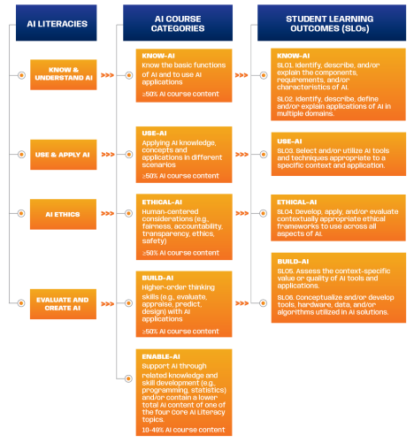
This image captures how AI literacies are mapped to course categories which then require certain student learning outcomes.
These SLOs form the backbone of the AI undergraduate curriculum, ensuring that each AI designated course contributes meaningfully to student competence. Faculty assess student performance against these outcomes enabling consistent measurement across disciplines. The AI² Center compiles and analyzes this data each semester, feeding results into institutional reporting systems to inform course improvements, faculty development, and overall strategic planning.
Results are reported to institutional leadership to inform continuous improvement. Early metrics indicate strong adoption: approximately 300 faculty members are involved in AI-related activities, offering over 230 AI-designated courses across 16 colleges. Courses range from high-enrollment, high-impact courses for all business undergraduates to electives that rely on interested students in a particular area.
Other measures of success include enrollment in AI courses, (unique) students taking AI courses per academic year, students completing certificates, AI courses and student enrollment per college, and the number of faculty and K-12 teachers completing professional development.
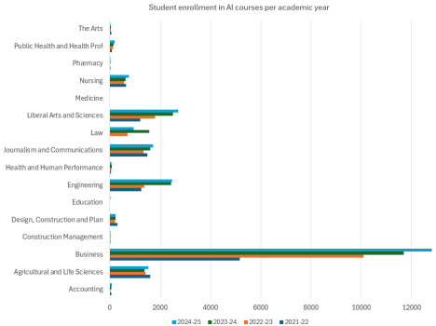
This image captures the growth of student enrollment in AI courses across the University of Florida between the 2021-2022 and 2024-2025 academic years.
How-To Takeaway: Establish a consistent assessment system by anchoring every AI designated course to shared Student Learning Outcomes (SLOs) and requiring faculty to evaluate student performance using a standardized rubric. Centralize data collection within a coordinating unit—such as the AI² Center—to analyze trends each semester and feed results into institutional reporting. Use this continuous feedback loop to refine courses, target faculty development, and guide strategic planning. Regularly share outcomes with university leadership to maintain momentum, demonstrate impact, and support long-term sustainability.
Lessons Learned and Recommendations for Other Institutions
UF’s experience offers several actionable lessons for universities aiming to implement AI across the curriculum:
1. Establish a central coordinating hub outside of any individual college or department. This ensures neutrality, resource equity, and streamlined governance.
2. Define core AI competencies early and map all courses to these competencies for clarity, scalability, and assessment alignment.
3. Create structured governance and review processes, including a body to outline criteria and designate courses as AI.
4. Incentivize faculty participation with professional development, financial support, and recognition programs.
5. Integrate assessment into institutional reporting systems to track progress and drive continuous improvement.
Success depends on institutional commitment, cross-college collaboration, and consistent communication of goals.
AI Across the Curriculum: Three-Year Roadmap Year 1: Build Vision, Structure, and Governance
• Establish an institution-wide AI literacy vision tied to workforce needs. • Define core AI competencies and shared Student Learning Outcomes (SLOs). • Stand up a central coordinating unit (AI center) with staffing and budget. • Form a cross-college AI Education Committee to review and tag courses.
• Launch initial faculty development workshops and modest incentives for course creation. Outcome: Shared vision, governance, and foundational structures are in place. Year 2: Develop Framework and Launch Pilot Courses
• Finalize the AI course taxonomy and adopt a catalog tagging system. • Run the full approval workflow: faculty → dean → AI Education Committee. • Expand faculty training via intensive workshops and microcredentials. • Launch the first cohort of AI-designated courses across multiple colleges. • Pilot rubric-based assessment aligned to the competency framework.
Outcome: Processes are operational; early AI-designated courses launch with consistent quality standards.
Year 3: Scale Curriculum and Student Pathways
• Grow the number and diversity of AI-designated courses across general education and majors.
• Launch undergraduate certificates and microcredential pathways for students.
• Increase student engagement through events, experiential learning, and career partnerships.
• Complete full assessment cycles and publish annual data to guide refinement. Outcome: AI instruction scales across campus, and structured student pathways take shape.
Sustaining the Momentum
The AI² Center, although small in staff, functions as the engine for UF’s AI curriculum, ensuring that programs remain sustainable, inclusive, and adaptable. Its combination of strategic leadership, faculty support, and centralized assessment creates a durable framework that does not depend on any single individual or department.
The key takeaway for other institutions is clear: integrating AI across the curriculum is not primarily a technological challenge. It is an organizational and cultural one. By combining central coordination, clearly defined competencies, robust governance, and faculty and student engagement strategies, universities can build an AI-literate campus prepared for the demands of the 21st century.

